1. [**Description of models**](https://flexagon.com/blog/7-software-development-models-you-should-know/)
2. **Explain Agile Process Model**.

Agile SDLC model is a combination of iterative and incremental process models with focus on process adaptability and customer satisfaction by rapid delivery of working software products.

Agile Methods break the product into small incremental builds. These builds are provided in iterations. Each iteration typically lasts from about one to three weeks. Every iteration involves cross functional teams working simultaneously on various areas like planning, requirements analysis, design, coding, unit testing, and acceptance testing.

At the end of the iteration a working product is displayed to the customer and important stakeholders.

The Agile model believes that every project needs to be handled differently and the existing methods need to be tailored to best suit the project requirements. In agile the tasks are divided into time boxes (small time frames) to deliver specific features for a release.

Iterative approach is taken and working software build is delivered after each iteration. Each build is incremental in terms of features; the final build holds all the features required by the customer.

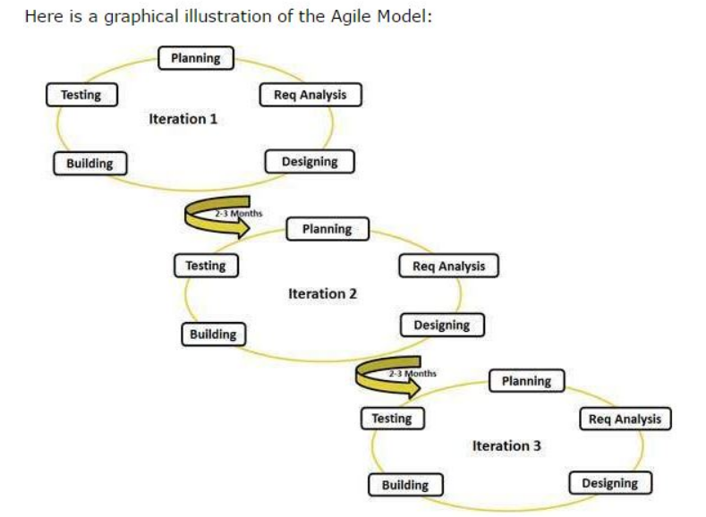

Agile thought process had started early in the software development and started becoming popular with time due to its **flexibility** and **adaptability**.

**Advantages** of Agile model:

**Customer satisfaction** by rapid, continuous delivery of useful software.

**People and interactions are emphasized** rather than process and tools.

Customers, developers and testers constantly interact with each other.

**Working software** is delivered **frequently** (weeks rather than months).

**Face-to-face conversation** is the best form of communication.

Close, **daily cooperation** between business people and developers.

**Continuous attention** to technical excellence and good design.

**Regular adaptation** to changing circumstances.

Even **late changes** in requirements are **welcomed**

**Disadvantages**:

Less documentation

Maintenance problem

Lack of testing strategy

Not changing the objectives

**Agile Process Models:**

Extreme Programming (XP)

Adaptive Software Development (ASD)

Dynamic Systems Development Method (DSDM)

Scrum

Crystal

List item

Feature Driven Development (FDD)

Agile Modeling (AM)

**steps in agile process model**

The Agile process model is based on iterative and incremental development. **i**Here are the 7 typical steps in the Agile process model:

1. **Project planning**: In this step, the team defines the scope of the project, identifies the stakeholders, and creates a product backlog, which is a prioritized list of features and requirements.
2. **Sprint planning:** The team selects a set of items from the product backlog to work on during the upcoming sprint. The team also defines the sprint goal and creates a sprint backlog, which is a detailed plan for the sprint.
3. **Sprint execution:** During this step, the team works on the items in the sprint backlog, using iterative development cycles to continuously build, test, and integrate the software.
4. **Daily stand-up meetings**: The team meets daily to discuss progress, identify any obstacles, and plan the work for the next 24 hours.
5. **Sprint review:** At the end of each sprint, the team demonstrates the working software to stakeholders, collects feedback, and adjusts the product backlog as needed.
6. **Sprint retrospective**: The team reflects on the previous sprint, identifies what went well and what could be improved, and defines action items for the next sprint.
7. **Repeat**: The team repeats these steps for each sprint until the project is complete.

Throughout the Agile process, **communication** and **collaboration** among team members and stakeholders is key. The team works **closely with the customer** to ensure that the software meets their needs, and adjusts the plan as needed based on **feedback** and **changing priorities.**

1. **Explain Kanban Model.**

Kanban is a software development methodology that emphasizes **visual management, continuous delivery, and incremental improvement.** The name "Kanban" comes from the Japanese word for "visual signal," which refers to the use of a visual board to track work in progress.

In the Kanban model, work is broken down into small, manageable pieces and each piece is represented by a card or sticky note on a Kanban board. The board is typically divided into columns representing the stages of the development process, such as "to do," "in progress," and "done." Each card is moved across the board as it progresses through the stages of the process, providing a visual representation of the work in progress.

The Kanban model has several **key principles:**

**Visual management**: The use of a visual board to track work in progress provides a **clear** and **transparent view** of the development process, helping to identify bottlenecks and improve efficiency.

**Limiting work in progress:** The number of cards allowed in each column is limited, preventing the team from taking on too much work at once and helping to maintain a steady flow of work.

**Continuous delivery:** Work is delivered in small, frequent increments, allowing the team to quickly respond to changing requirements and feedback from stakeholders.

**Continuous improvement:** The team regularly reviews and reflects on their process, identifying areas for improvement and making incremental changes to improve efficiency and quality.

The Kanban model is **flexible** and **adaptable**, making it well-suited for teams that work in a **dynamic** and **changing environment.** It is often used in Agile software development, but can be applied to other types of projects as well. The focus on visual management and continuous improvement helps teams to **identify and address issues quickly, leading to a more efficient and effective development process. - advantage**

**steps in kanban model**

The Kanban model is a software development methodology that emphasizes visual management, continuous delivery, and incremental improvement. Here are the typical steps in the Kanban model:

**Visualize the workflow:** The team maps out the development process and creates a visual board, such as a whiteboard or electronic tool, to **represent the workflow.** Each stage of the process is represented by a column on the board.

**Define work items:** Work items are broken down into small, manageable pieces and each piece is represented by a card or sticky note on the Kanban board.

**Limit work in progress:** The number of cards allowed in each column is limited, preventing the team from taking on too much work at once and helping to maintain a steady flow of work.

**Implement pull-based system:** Work is pulled into the next column only when there is available capacity, rather than being pushed from the previous column.

**Continuous delivery**: Work is delivered in small, frequent increments, allowing the team to quickly respond to changing requirements and feedback from stakeholders.

**Continuous improvement**: The team regularly reviews and reflects on their process, identifying areas for improvement and making incremental changes to improve efficiency and quality.

**Manage flow**: The team tracks the flow of work across the board, identifying and addressing bottlenecks and impediments to ensure a smooth and efficient process.

**Iterate**: The team repeats these steps, making incremental improvements to the process over time.

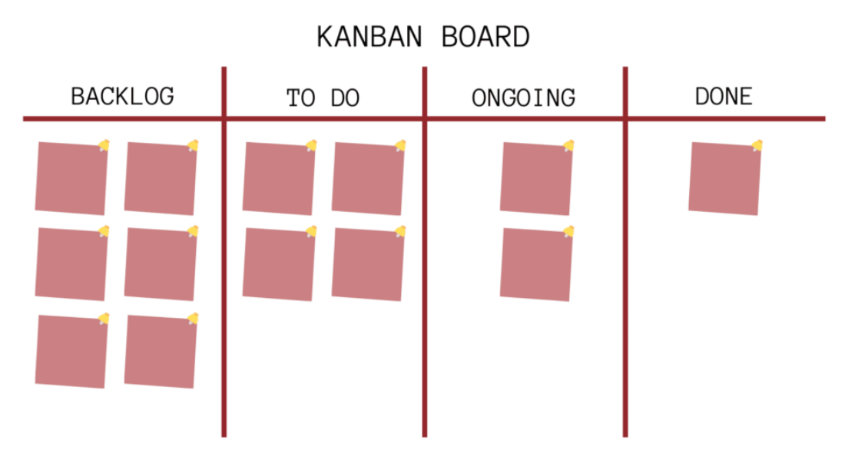

**Disadvantages**:

poor way to define and maintain timeframes

Planning long projects is very difficult.

Throughout the Kanban process, communication and collaboration among team members and stakeholders is key. The team works closely with the customer to ensure that the software meets their needs, and adjusts the plan as needed based on feedback and changing priorities. (The focus on visual management and continuous improvement helps teams to identify and address issues quickly, leading to a more efficient and effective development process.) - **advantage**

1. **Explain Evolutionary process model**

The evolutionary process model is an **iterative and incremental** software development methodology that involves **delivering a basic working version** of the software and then **refining** it **through a series of iterations.** The model is based on the idea of **continuous improvement**, with each iteration building on the previous one to produce a final product that meets the customer's needs.

Here are the typical steps in the evolutionary process model:

**Requirements gathering**: The team works with the customer to gather requirements and define the initial scope of the project.

**Prototype development:** A basic working version of the software is developed, based on the initial requirements. The prototype is not a final product, but rather a starting point for the iterative development process.

**Evaluation**: The customer evaluates the prototype and provides feedback on its functionality, usability, and other aspects.

**Iterative development**: The team works on refining the software based on the customer's feedback, delivering a new version at the end of each iteration.

**Testing**: Testing is conducted throughout the development process to ensure that the software meets the customer's requirements and is free of errors.

**Delivery**: The final version of the software is delivered to the customer, meeting their requirements and expectations.

**Maintenance**: The software is maintained and updated as needed to ensure that it continues to meet the customer's needs and remains up-to-date.

(The evolutionary process model is **highly flexible and adaptable**, making it well-suited for projects with changing requirements or uncertain scope. It allows the team to **quickly respond to customer feedback** and make changes as needed, leading to a final product that meets the customer's needs and expectations. However, the model can be **more time-consuming and costly** than other software development methodologies, as it involves multiple iterations of development and testing.) - **adv and disadvantages**

1. **With a neat diagram explain the spiral model of software development.**

The spiral model is similar to the **incremental model**, with more **emphasis placed on risk analysis.** The spiral model has **four phases:** Planning, Risk Analysis, Engineering and Evaluation.

A software project repeatedly passes through these phases in iterations (called Spirals in this model).

The baseline spiral, starting in the planning phase, **requirements** are **gathered** and **risk** is **assessed**. Each subsequent spirals builds on the baseline spiral.

**Planning Phase:** Requirements are gathered during the planning phase. Requirements like ‘BRS’ that is ‘Bussiness Requirement Specifications’ and ‘SRS’ that is ‘System Requirement specifications’.

**Risk Analysis:** In the risk analysis phase, a process is undertaken to identify risk and alternate solutions. A **prototype** is **produced** at the end of the risk analysis phase. If any risk is found during the risk analysis then **alternate solutions are suggested and implemented.**

**Engineering Phase:** In this phase software is developed, along with testing at the end of the phase. Hence in this phase the development and testing is done.

**Evaluation phase:** This phase allows the customer to evaluate the output of the project to date before the project continues to the next spiral.

Diagram of Spiral model:

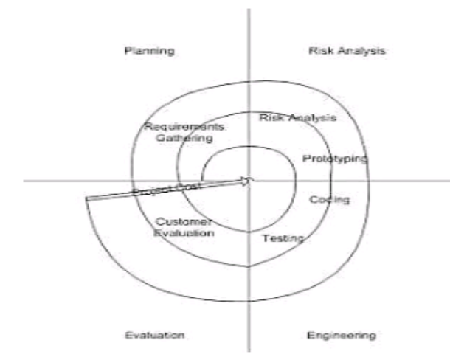

**Advantages of Spiral model:**

High amount of risk analysis hence, **avoidance of Risk is enhanced.**

Good for **large** and mission-critical **projects**.

**Strong approval** and documentation control.

Additional Functionality can be added at a later date.

**Software** is **produced early** in the software life cycle.

**Disadvantages of Spiral model:**

Can be a **costly** model to use.

Risk analysis requires **highly specific expertise.**

Project’s **success** is **highly dependent** on the risk analysis phase.

**Doesn’t** work well for **smaller projects**.

**When to use Spiral model:**

When costs and risk evaluation is important

For medium to high-risk projects

Long-term project commitment unwise because of potential changes to economic priorities

Users are unsure of their needs

Requirements are complex

New product line

Significant changes are expected (research and exploration)

1. **Write short note on: SCRUM**

Scrum is an Agile software development framework that emphasizes **collaboration, iterative development, and continuous improvement.** It is a popular methodology for managing complex projects and is particularly well-suited to projects with rapidly changing requirements.

Here are the typical steps in the Scrum process:

**Product Backlog Creation**: The product owner creates a product backlog, which is a **prioritized list of features,** bug fixes, and other development tasks.

**Sprint Planning**: The Scrum team plans the upcoming sprint, which is a **short iteration of development work** typically lasting two to four weeks. The team selects items from the product backlog and **defines the sprint goals and deliverables.**

**Sprint Execution**: The Scrum team develops the selected items during the sprint, with daily meetings to monitor progress and address any issues.

**Sprint Review**: At the end of the sprint, the team demonstrates the completed work to the product owner and stakeholders, and **feedback is gathered** to inform the next sprint.

**Sprint Retrospective**: The Scrum team reflects on the sprint, identifying what went well, what didn't go well, and areas for improvement. The team then creates a plan to implement changes and improvements in the next sprint.

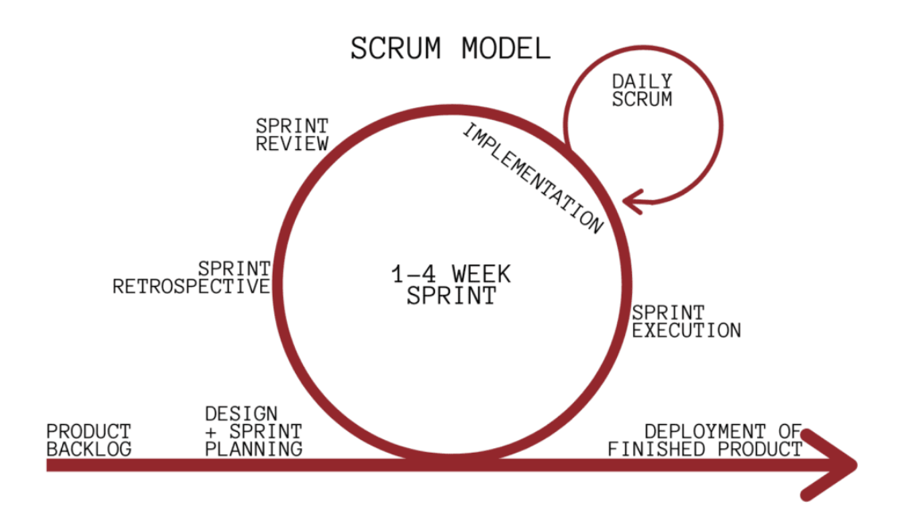

**Advantages** of Scrum:

**Flexibility**: Scrum is highly flexible, with a focus on **adaptability** and **responsiveness** to changing requirements and priorities.

**Collaboration**: Scrum emphasizes collaboration and teamwork, with a focus on continuous improvement and learning.

**Transparency**: Scrum provides transparency into the development process, with **frequent updates** and **opportunities** for **feedback** and **review**.

**Faster Time to Market**: Scrum allows teams to deliver working software quickly and frequently, which can accelerate time to market and provide early value to stakeholders.

**Disadvantages** of Scrum:

**Complexity**: Scrum can be complex to implement, requiring a high degree of organization, planning, and communication.

**Resource Requirements**: Scrum requires significant resources, including time, personnel, and infrastructure, which can be a barrier to adoption for some teams.

**Uncertainty**: Scrum's focus on flexibility and adaptability can also create uncertainty, as requirements and priorities can change rapidly.

**Overemphasis on Process**: Scrum can sometimes lead to an overemphasis on process and methodology, rather than on actual software development and delivery.

Overall, Scrum can be an effective software development methodology for complex projects with rapidly changing requirements. However, its implementation requires careful planning and management, and teams must be prepared to invest significant time and resources in the development process.

Scrum is a subset of Agile. It is a **lightweight process framework** for agile development, and the most widely-used one.

A “process framework” is a **particular set of practices that must be followed in order for a process to be consistent with the framework**. (For example, the Scrum process framework requires the use of development cycles called Sprints, the XP framework requires pair programming, and so forth.)

“Lightweight” means that the overhead of the process is kept as small as possible, to maximize the amount of productive time available for getting useful work done.

A Scrum process is distinguished from other agile processes by specific concepts and practices, divided into the three categories of Roles, Artifacts, and Time Boxes. These and other terms used in Scrum are defined below.

Scrum is most often used to manage complex software and product development, using iterative and incremental practices. Scrum significantly increases productivity and reduces time to benefits relative to classic “waterfall” processes. Scrum processes enable organizations to adjust smoothly to rapidly-changing requirements, and produce a product that meets evolving business goals.

An agile Scrum process benefits the organization by helping it to

Increase the quality of the deliverables

Cope better with change (and expect the changes)

Provide better estimates while spending less time creating them

Be more in control of the project schedule and state

**Scrum has three roles**: Product Owner, Scrum Master, and Team.

**Product Owner**: The Product Owner should be a person with vision, authority, and availability. The Product Owner is responsible for continuously communicating the vision and priorities to the development team. It’s sometimes hard for Product Owners to strike the right balance of involvement. Because Scrum values self-organization among teams, a Product Owner must fight the urge to micro-manage. At the same time, Product Owners must be available to answer questions from the team.

**Scrum Master**: The Scrum Master acts as a **facilitator** for the **Product Owner** and the team. The Scrum Master does not manage the team. The Scrum Master works to **remove any impediments that are obstructing the team from achieving its sprint goals.** This helps the team remain creative and productive while making sure its successes are visible to the Product Owner. The Scrum Master also works to **advise the Product Owner** about how to **maximize ROI** for the team.

**Team**: According to Scrum’s founder, “the team is utterly self- managing.” The development team is responsible for self- organizing to complete work. A Scrum development team contains about seven fully dedicated members (officially 3-9), ideally in one team room protected from outside distractions. For software projects, a typical team includes a mix of software engineers, architects, programmers, analysts, QA experts, testers, and UI designers. Each sprint, the team is responsible for determining how it will accomplish the work to be completed. The team has autonomy and responsibility to meet the goals of the sprint.

7 .**Explain umbrella activities of software engineering**

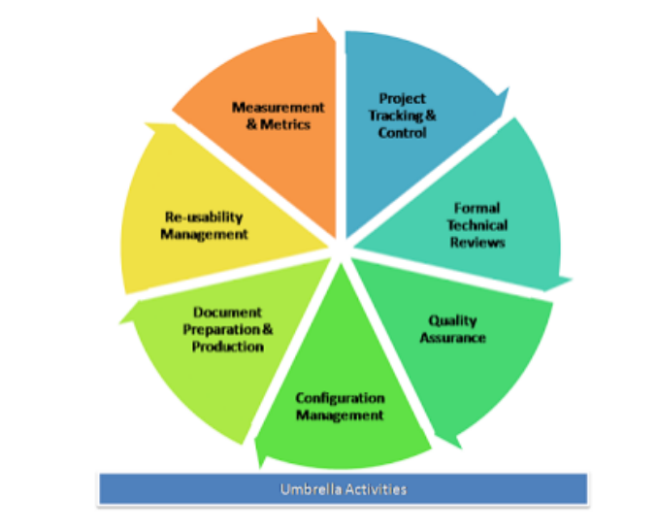

1. **Software project tracking and control:** When plan, tasks, models all have been done then a network of software engineering tasks that will enable to get the job done on time will have to be created.
2. **Formal technical reviews:** This includes reviewing the techniques that has been used in the project.
3. **Software quality assurance**: This is very important to ensure the quality measurement of each part to ensure them.
4. **Software configuration management**: Software configuration management (SCM) is a set of activities designed to control change by identifying the work products that are likely to change, establishing relationships among them, defining mechanisms for managing different versions of these work products.
5. **Document preparation and production:** All the project planning and other activities should be hardly copied and the production gets started here.
6. **Reusability management:** This includes the backing up of each part of the software project. They can be corrected or any kind of support can be given to them later to update or upgrade the software at user/time demand.
7. **Measurement & Metrics**: This will include all the measurements of every aspect of the software project.
8. **Risk management**: Risk management is a series of steps that help a software team to understand and manage uncertainty. It’s a really good idea to identify it, assess its probability of occurrence, estimate its impact, and establish a contingency plan that─ ‘should the problem actually occur’.

.

1. **Differentiate between waterfall and spiral model.**

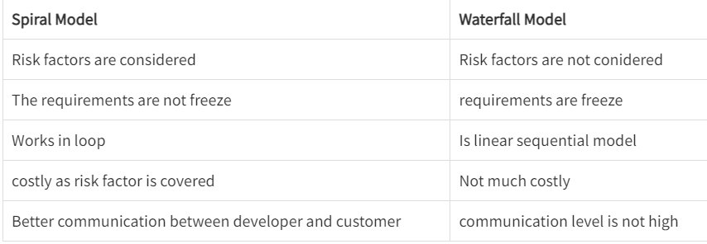

1. **Explain 3 P’s of software engineering.**

The 3 P's of software engineering are People, Process, and Product. These are the essential components that affect the success of any software project. Here's an explanation of each P:

**People**:

The people involved in a software project include developers, testers, project managers, and other stakeholders. People are the most critical factor in software development, as they contribute to the project's success through their skills, experience, and collaboration. People's skills and teamwork can significantly impact the project's outcome.

**Process**:

The process is the **methodology used to develop the software**, and it defines the stages of development, roles and responsibilities, and the tools and techniques used. An efficient and effective process helps ensure quality, predictability, and on-time delivery of the software product. Process improvement is a continuous effort to improve efficiency and effectiveness.

**Product**:

The software product is the end result of the development process. The product should meet the user's requirements and expectations, be of high quality, be delivered on time, and be cost-effective. The product is the output of the development process, and its success depends on the quality of the process and people involved.

The 3 P's of software engineering help in understanding the factors that influence the success of software projects. A well-defined and well-executed process, a skilled team of developers and stakeholders, and a high-quality software product are the key factors that contribute to the success of software projects.

1. **Compare the main features and practices at each of the key phases of the agile approach and more traditional approaches of the software development life cycle.**

Agile and traditional approaches to software development have different key phases and practices. Here is a comparison of the main features and practices at each phase:

**Requirements gathering and analysis:**

In traditional approaches, the requirements gathering and analysis phase is typically long and involves a detailed specification document. In contrast, in agile approaches, the focus is on continuous collaboration between the development team and the customer, with requirements evolving over time.

**Design**:

In traditional approaches, the design phase follows the requirements phase and typically involves creating detailed design documents. In agile approaches, design is an ongoing process that happens alongside development, with the emphasis on delivering working software quickly.

**Development**:

In traditional approaches, development is a separate phase that follows design, with a focus on producing a fully functional product before testing. In agile approaches, development is iterative and collaborative, with frequent releases and continuous integration.

**Testing**:

In traditional approaches, testing is a separate phase that follows development, with a focus on finding and fixing bugs. In agile approaches, testing is integrated into the development process, with frequent automated testing and continuous feedback from the customer.

**Deployment**:

In traditional approaches, deployment is a separate phase that follows testing, with a focus on ensuring the software is ready for release. In agile approaches, deployment is integrated into the development process, with frequent releases and continuous deployment.

**Maintenance**:

In traditional approaches, maintenance is a separate phase that follows deployment, with a focus on bug fixing and support. In agile approaches, maintenance is ongoing, with continuous improvement and new features added in each release.

Overall, the main differences between traditional and agile approaches to software development are the focus on collaboration, flexibility, and continuous improvement in agile approaches. Agile approaches emphasize delivering working software quickly, with frequent feedback from the customer and a focus on adapting to changing requirements. Traditional approaches, on the other hand, emphasize detailed planning, documentation, and a structured approach to development.

1. **What is software engineering? Explain RAD model with diagram.**

Software engineering is the **process of designing, developing, testing, and maintaining software using a systematic approach**. The goal of software engineering is to **create high-quality software** that is reliable, efficient, and meets the needs of its users.

The Rapid Application Development Model was first proposed by IBM in the 1980s. The RAD model is a type of incremental process model in which there is extremely short development cycle. When the requirements are fully understood and the component based construction approach is adopted then the RAD model is used. Various phases in RAD are Requirements Gathering, Analysis and Planning, Design, Build or Construction and finally Deployment.

The critical feature of this model is the use of powerful development tools and techniques. A software project can be implemented using this model if the project can be broken down into small modules wherein each module can be assigned independently to separate teams. These modules can finally be combined to form the final product. Development of each module involves the various basic steps as in the waterfall model i.e analyzing, designing, coding, and then testing, etc. as shown in the figure. Another striking feature of this model is a short time span i.e the time frame for delivery(time-box) is generally 60-90 days.

Requirements Planning – It involves the use of various techniques used in requirements elicitation like brainstorming, task analysis, form analysis, user scenarios, FAST (Facilitated Application Development Technique), etc. It also consists of the entire structured plan describing the critical data, methods to obtain it, and then processing it to form a final refined model.

User Description – This phase consists of taking user feedback and building the prototype using developer tools. In other words, it includes re-examination and validation of the data collected in the first phase. The dataset attributes are also identified and elucidated in this phase.

Construction – In this phase, refinement of the prototype and delivery takes place. It includes the actual use of powerful automated tools to transform process and data models into the final working product. All the required modifications and enhancements are too done in this phase.

Cutover – All the interfaces between the independent modules developed by separate teams have to be tested properly. The use of powerfully automated tools and subparts makes testing easier. This is followed by acceptance testing by the user.

The process involves building a rapid prototype, delivering it to the customer, and taking feedback. After validation by the customer, the SRS document is developed and the design is finalized.

1. **Explain elements of the analysis model.**

A graphical representations of **business processes**, the **problems** to be

**solved**, and the new proposed product (software).

**Objectives**:

To describe software requirements.

To establish a basis for the creation of a software design.

To define a set of requirements that can be validated once the software is

Built.

Bridges the gap between a software specification and a software design.

**Elements of the analysis model**

1. **Scenario based element**

This type of element represents the system user point of view.

Scenario based elements are use case diagrams, user stories.

2. **Class based elements**

The object of this type of element is manipulated by the system.

It defines the object,attributes and relationship.

The collaboration is occurring between the classes.

Class based elements are the class diagram, collaboration diagram.

3. **Behavioral elements**

Behavioral elements represent the state of the system and how it is changed by the external events.

The behavioral elements are sequenced diagram, state diagram.

4. **Flow oriented elements**

Information flows through a computer-based system and it gets transformed.

It shows how the data objects are transformed while they flow between the various system functions.

The flow elements are data flow diagram, control flow diagram.

The rules of thumb that must be followed while creating the analysis model.

**The rules are as follows:**

1. The model focuses on the requirements in the business domain. The level of abstraction must be high i.e there is no need to give details.
2. Every element in the model helps in understanding the software requirement and focuses on the information, function and behavior of the system.
3. The consideration of infrastructure and nonfunctional models were delayed in the design.
4. For example, the database is required for a system, but the classes, functions and behavior of the database are not initially required. If these are initially considered then there is a delay in the design.
5. Throughout the system minimum coupling is required. The interconnection between the modules is known as 'coupling'.
6. The analysis model gives value to all the people related to the model.
7. The model should be as simple as possible. Because a simple model always helps in easy understanding of the requirement.
8. **What is Cost Estimation? Explain LOC Method.**

Cost estimation is the process of predicting the cost of a software project. It is an essential aspect of software project management, as accurate cost estimation helps in effective budgeting and resource allocation. One of the methods used for cost estimation in software development is the Lines of Code (LOC) method.

The LOC method is a technique that estimates the cost of a software project based on the number of lines of code (LOC) that will be written. The method involves the following steps:

Determine the size of the project: The first step is to estimate the size of the software project in terms of the number of lines of code that will be written. This can be done by reviewing the project requirements and specifications.

Determine the cost per line of code: Once the size of the project has been estimated, the next step is to determine the cost per line of code. This can be done by analyzing historical data or industry benchmarks for similar projects.

Multiply the size of the project by the cost per line of code: The final step is to multiply the estimated size of the project by the cost per line of code to get the estimated cost of the project.

The LOC method has several advantages, including:

Simplicity: The LOC method is simple and easy to understand, making it a popular choice for cost estimation.

Accuracy: The LOC method can be accurate if the project size and cost per line of code are estimated correctly.

However, the LOC method also has some disadvantages, including:

Dependency on lines of code: The LOC method relies on the number of lines of code to estimate the project cost, which may not always be a good measure of complexity or effort.

Lack of consideration for other factors: The LOC method does not consider other factors that can impact project cost, such as team experience, technology, and project scope.

In summary, the LOC method is a straightforward technique for cost estimation in software development that relies on the number of lines of code. While it has its advantages, it is important to consider other factors and use multiple estimation techniques for more accurate cost predictions.

1. **Develop a SRS for Hospital.**

Software Requirement Specification (SRS) for Hospital Management System

Introduction

The Hospital Management System (HMS) is an integrated software application designed to manage various aspects of a hospital's operations, including patient registration, appointment scheduling, doctor and nurse management, billing, and inventory management. The system is intended to provide an efficient and streamlined approach to hospital management, helping to improve patient care and reduce administrative overhead.

Scope

The HMS will be a web-based application that can be accessed by authorized personnel from any location with an internet connection. The system will be designed to meet the needs of a small to medium-sized hospital, with the ability to scale up as the hospital grows.

Functional Requirements

The following are the functional requirements of the HMS:

3.1 Patient Registration

The system should allow hospital staff to register new patients, including basic information such as name, address, and contact details. The system should also allow for the creation of patient profiles, including medical history and any relevant allergies or health conditions.

3.2 Appointment Scheduling

The system should allow for the scheduling of appointments between patients and doctors, including the ability to view the doctor's availability and schedule appointments accordingly.

3.3 Doctor and Nurse Management

The system should allow for the management of doctors and nurses, including the ability to view their schedules, assign patients, and manage their availability.

3.4 Billing and Insurance Management

The system should allow for the management of billing and insurance claims, including the ability to generate invoices, track payments, and manage insurance claims.

3.5 Inventory Management

The system should allow for the management of hospital inventory, including the ability to track supplies and equipment, manage stock levels, and order new supplies as needed.

Non-Functional Requirements

The following are the non-functional requirements of the HMS:

4.1 Performance

The system should be able to handle a large number of users simultaneously, without experiencing any significant performance issues.

4.2 Security

The system should be designed to ensure the security and confidentiality of patient data, including the use of secure login credentials and data encryption.

4.3 User Interface

The system should have a user-friendly interface that is easy to navigate and use, with clear and concise instructions and labels.

Constraints

The following are the constraints of the HMS:

5.1 Compatibility

The system should be compatible with a range of devices and operating systems, including desktop and mobile devices.

5.2 Scalability

The system should be designed to scale up as the hospital grows, with the ability to add new features and functionality as needed.

Assumptions and Dependencies

The following are the assumptions and dependencies of the HMS:

6.1 Training

Hospital staff will receive adequate training on how to use the system, including training on any new features or functionality that are added in the future.

6.2 Hardware and Infrastructure

The hospital will have the necessary hardware and infrastructure in place to support the system, including internet connectivity and server resources.

Conclusion

The Hospital Management System is a comprehensive software application designed to manage various aspects of hospital operations. The system is intended to provide an efficient and streamlined approach to hospital management, helping to improve patient care and reduce administrative overhead.

1. **Draw the Data Flow diagram(upto 2 level) for the safe home software**

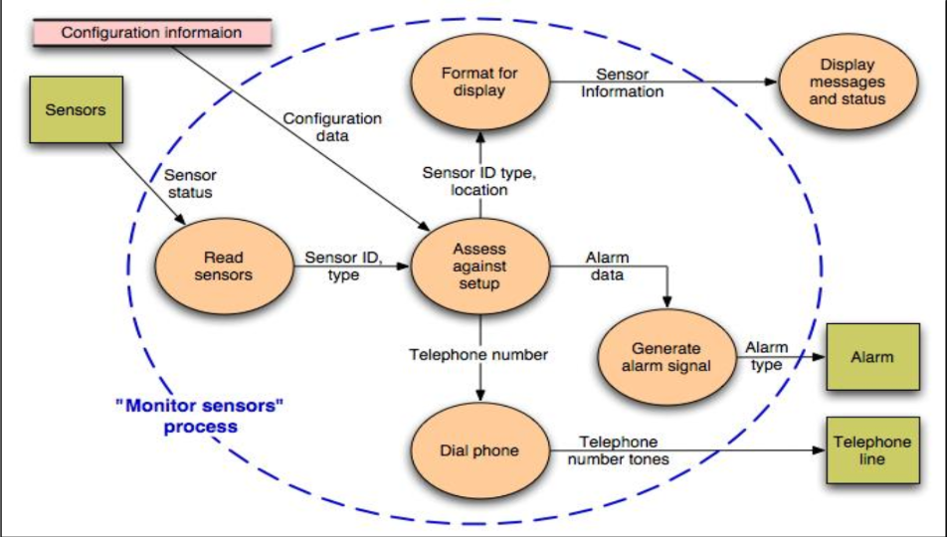

1. **Explain requirement elicitation in detail. Explain any two methods**

Requirement elicitation is the process of discovering, analyzing, and documenting the needs and expectations of stakeholders for a software system. This is a crucial step in software development as it lays the foundation for the entire project. The goal of requirement elicitation is to identify the necessary features, functions, and constraints of the system in order to meet the stakeholders' needs and expectations.

There are several methods used for requirement elicitation, including:

Interviews: One of the most common methods for requirement elicitation is conducting interviews with stakeholders. Interviews can be conducted individually or in groups, and can be structured or unstructured. The purpose of the interview is to ask stakeholders open-ended questions to gather their perspectives on the system and its requirements.

Workshops: Workshops are another popular method for requirement elicitation. They involve bringing together stakeholders and development team members to discuss the system and its requirements. Workshops can be used to brainstorm ideas, identify user stories, and prioritize requirements.

Two other methods for requirement elicitation are:

Surveys: Surveys can be used to gather information from a large number of stakeholders in a cost-effective way. Surveys can be conducted online or in-person, and can be used to gather quantitative data on stakeholder needs and expectations.

Observations: Observations involve observing stakeholders in their natural environment to understand their needs and expectations for the system. This method can be useful for understanding how stakeholders currently perform tasks and identifying opportunities for improvement.

In general, effective requirement elicitation requires clear communication, active listening, and a thorough understanding of the stakeholders and their needs. It is important to use a combination of methods to ensure that all stakeholders are heard and that their needs are addressed. Additionally, requirement elicitation should be an iterative process, with regular feedback and refinement of requirements throughout the software development lifecycle.

1. **Explain feasibility studies in detail.**

As the name implies, feasibility study is an analysis of the viability of an idea. It ensures that a project is legally and technically feasible and economically justifiable.

Moreover this study can be used in various ways with focus on the proposed business. It tells us whether a project is worth doing or not? Feasibility study is a must because:

Every Project is not doable.

Not every project should be done.

Not every project makes use of the company's effective resources.

In its simplest terms, the two criteria to judge feasibility are cost required and value to be attained. A well-designed study should provide a historical background of the business or project, a description of the product or service, accounting statements, details of the operations and management, marketing research and policies, financial data, legal requirements and tax obligations. Generally, such studies precede technical development and project implementation.

Feasibility study is used for:

* To determine whether the objectives stated in the assignment brief are reasonably attainable within the limitation and financial constraints period.
* To define major problem areas, so that the system analyst can plan the strategy for the field investigation.
* To find areas where potential exists for making saving in money, time or effort.
* To determine the approximate time required for the full investigation and cost.
* To discover the areas where some specialist knowledge needed for the full investigation.

Five different areas of Project Feasibility:

Technical Feasibility assessment is focused on the present technical resource available in the organization. It studies if the technical resources including the technical team are capable of converting the ideas into working system. It also evaluates the hardware and the software requirement of the proposed system.

Economic Feasibility studies enable organizations to assess the viability, cost and benefits of projects before financial resources are allocated. They also provide independent project assessment and enhance project credibility. It also helps to determine the positive economic benefits to the organization that the proposed system will provide. It includes quantification and identification of all the benefits expected. This assessment typically involves a cost/ benefits analysis of the project.

Legally Feasibility of the project determines whether the proposed system conflicts with legal requirements like any data protection act or any social media law.

Operational Feasibility, under which we conduct a study to analyze and determine whether your business need can be fulfilled by using a proposed solution. It also measures how well a proposed system solves the problems, and takes advantage of the opportunities identified during scope definition and how it satisfies the requirements identified in the requirements analysis phase of system development.

Scheduling Feasibility is the most important in terms of project success. A project will fail if not completed on time. In scheduling feasibility we estimate how much time the system will take to complete and with our technical skill we need to estimate the period to complete the project using some methods.

Benefits

Conducting a feasibility study is always beneficial to the project and it gives a clear picture of your idea. Below are the top benefits of this study:

Gives focus to the project and alternative outline.

Narrows the business alternative.

Identifies the reason to do the project.

Enhances the success rate by considering multiple factor.

Helps in decision making of the project.

Provides a detailed documented status to the business.

1. **Short note on Process Metrics and project metrics.**

a) Process Metrics

These are the metrics pertaining to the Process Quality. They measure efficiency and effectiveness of various processes.

b) Project Metrics

These are the metrics pertaining to the Project Quality. They measure defects, cost, schedule, productivity and estimation of various project resources and deliverables.

Project Metrics -

Schedule Variance : Any difference between the scheduled completion of an activity and the actual completion is known as Schedule Variance. Schedule variance = ((Actual calendar days – Planned calendar days) + Start variance)/ Planned calendar days x 100.

Effort Variance: Difference between the planned outlined effort and the effort required to actually undertake the task is called Effort variance. Effort variance = (Actual Effort – Planned Effort)/ Planned Effort x 100.

Size Variance: Difference between the estimated size of the project and the actual size of the project (normally in KLOC or FP) Size variance = (Actual size – Estimated size)/ Estimated size x 100.

Requirement Stability Index: Provides visibility and understanding into the magnitude and impact of requirements changes. RSI = 1- ((No of changed + No of deleted + No of added) / Total no of Initial requirements) x100

Productivity (Project): It is a measure of output from a related process for a unit of input. Project Productivity = Actual Project Size / Actual Effort spent for the project

Productivity (for test case preparation) Productivity in test case preparation = Actual no of test cases/ actual effort spent on test case preparation

Productivity (for test case execution) Productivity in test case execution = actual number of test cases / actual effort spend on testing.

Productivity (defect detection) Productivity in defect detection = Actual number of defects (review + testing) / actual effort spent on (review + testing)

Productivity (defect fixation) Productivity in defect fixation = actual no of defects fixed/ actual effort spent on defect fixation

Schedule variance for a phase: The deviation between planned and actual schedule for the phases within a project. Schedule variance for a phase = (Actual Calendar days for a phase – Planned calendar days for a phase + Start variance for a phase)/ (Planned calendar days for a phase) x 100

Effort variance for a phase: The deviation between planned and actual effort for various phases within the project. Effort variance for a phase = (Actual effort for a phase – planned effort for a phase)/ (planned effort for a phase) x 100

Process Metrics:

Cost of Quality: It is a measure in terms of money for the quality performance within an organization Cost of quality = (review + testing + verification review + verification testing + QA + configuration management + measurement + training + rework review + rework testing)/ total effort x 100

Cost of poor Quality: It is the cost of implementing imperfect processes and products. Cost of poor quality = rework effort/ total effort x 100

Defect Density: It is the number of defects detected in the software during the development divided by the size of the software (typically in KLOC or FP) Defect density for a project = Total number of defects/ project size in KLOC or FP

Review Efficiency: defined as the efficiency in harnessing/ detecting review defects in the verification stage. Review efficiency = (number of defects caught in review)/ total number of defects caught) x 100

Testing Efficiency: Testing efficiency = 1 – ((defects found in acceptance)/ total no of testing defects) x 100

Defect removal efficiency: Gives the efficiency with which defects were detected and minimum defects were filtered down to the customer. Defect removal efficiency = (1 – (total defects caught by customer/ total no of defects)) x 100

1. Explain Mc Calls Quality Factor?

McCall's Quality Factor Model is a software quality model that was first introduced by John McCall in 1977. The model is based on the idea that software quality can be assessed using a set of 11 quality factors, which are grouped into three categories: product operation, product revision, and product transition.

The 11 quality factors in McCall's Quality Factor Model are as follows:

**Correctness:** The degree to which the software meets its specified requirements and performs its intended functions accurately.

**Efficiency**: The degree to which the software performs its functions quickly and with minimal resource consumption.

**Integrity**: The degree to which the software is protected from unauthorized access, alteration, or destruction.

**Usability:** The degree to which the software is easy to use, understand, and learn.

**Maintainability:** The degree to which the software can be modified or updated easily, without introducing errors or defects.

**Testability:** The degree to which the software can be tested thoroughly to ensure that it meets its requirements and performs its intended functions.

**Flexibility:** The degree to which the software can be adapted to changing requirements or environments.

**Portability:** The degree to which the software can be moved from one environment or platform to another without requiring significant modification.

**Reusability**: The degree to which the software components can be reused in other software applications or systems.

**Interoperability**: The degree to which the software can interact and work effectively with other software components or systems.

**Understandability:** The degree to which the software is easy to comprehend and maintain by developers, users, and other stakeholders.

Overall, McCall's Quality Factor Model provides a comprehensive framework for assessing software quality, taking into account a wide range of factors that contribute to the overall quality of the software product. By evaluating software quality based on these 11 factors, software developers and testers can ensure that the software meets the requirements and expectations of its users, while minimizing defects and errors.

1. **What are the potential problems of prototyping models?**

While prototyping can be a valuable approach to software development, there are also some potential problems that can arise. Here are some of the most common problems associated with prototyping models:

Incomplete or inadequate requirements: Prototyping can be a risky approach if the requirements of the system are not fully understood. The prototypes produced may not fully meet the needs of the stakeholders or may not provide a complete solution to the problem.

Overemphasis on design and features: In some cases, prototyping can lead to an overemphasis on design and features, at the expense of other important aspects of software development, such as performance, security, and maintainability.

Limited scalability: Prototyping is often focused on a specific use case or a limited set of requirements, which can make it difficult to scale the system to meet broader needs or to accommodate changes in requirements.

Inadequate documentation: Prototyping models may not produce adequate documentation or may lack the necessary detail to fully understand the system.

Increased development costs: While prototyping can lead to faster development times in some cases, it can also lead to increased development costs if the prototypes need to be continually refined and revised.

Poor software quality: Prototyping may result in software that is less reliable, less secure, or more difficult to maintain over time.

Limited stakeholder involvement: If the stakeholders are not fully involved in the prototyping process, the prototypes produced may not fully meet their needs or expectations.

Overall, while prototyping can be a useful approach in some situations, it is important to carefully consider the potential problems and to use prototyping models judiciously to ensure that the software developed meets the needs of the stakeholders and is of high quality.

1. Write a note on: Service Oriented Software Engineering, Security Engineering.

**Service-Oriented Software Engineering** (SOSE) is an approach to software development that focuses on the creation of modular and reusable services. The approach is based on the Service-Oriented Architecture (SOA) paradigm, which views software applications as a collection of independent services that can be combined and reused to meet the needs of different applications.

SOSE involves the use of a set of principles, techniques, and tools to design, implement, and manage software services. These include:

Service modeling: This involves identifying the services that are required to meet the needs of a particular application, and defining their functional and non-functional requirements.

Service design: This involves defining the structure, behavior, and interfaces of the services, using a range of design patterns and standards.

Service implementation: This involves creating the services using a range of programming languages and platforms, and testing them to ensure that they meet their requirements.

Service composition: This involves combining the services to create more complex applications, using a range of integration techniques and standards.

Service management: This involves monitoring, maintaining, and optimizing the services, to ensure that they are performing as expected and meeting their service level agreements.

The key benefits of SOSE include increased modularity, reusability, flexibility, and scalability of software applications. By breaking down applications into smaller, independent services, developers can create more flexible and scalable applications that can be easily modified and adapted to changing requirements.

However, SOSE also presents some challenges, such as the need to manage service dependencies, ensure interoperability between different services, and provide adequate security and privacy measures to protect sensitive data. These challenges can be addressed through the use of appropriate design patterns, standards, and best practices, as well as the use of specialized tools and platforms for service management and integration.

**Security Engineering:**

Security engineering is a process of designing and building secure systems to protect against potential threats and attacks. It involves a set of principles, practices, and technologies that are used to develop systems that are resistant to both accidental and malicious attacks.

The key aspects of security engineering include:

Risk assessment: This involves identifying potential security threats and assessing their impact on the system, as well as evaluating the likelihood of the threat occurring.

Security design: This involves designing the system architecture, protocols, and algorithms to ensure that the system is secure and resistant to attacks.

Security implementation: This involves implementing the security features of the system, such as access control mechanisms, encryption, and authentication protocols.

Security testing: This involves testing the security features of the system to ensure that they are functioning as intended and are providing adequate protection against potential threats.

Security maintenance: This involves monitoring the system for potential security breaches, updating security features, and fixing any security vulnerabilities that are identified.

Security engineering is essential in ensuring the confidentiality, integrity, and availability of data and resources in a system. By following a systematic approach to security engineering, organizations can develop systems that are less vulnerable to attacks, and can minimize the risks of data breaches, theft, and other security threats.

Security engineering is used in a range of applications, including software systems, networks, and IoT devices. It is also an essential aspect of cybersecurity, where it is used to develop effective security strategies and policies for protecting against cyber threats.

1. El**aborate COCOMO method of cost estimation.**

COCOMO, or the Constructive Cost Model, is a widely used method for estimating the cost of software development projects. COCOMO was first introduced by Barry Boehm in 1981 and has since been revised and updated several times.

COCOMO is a parametric cost estimation model that uses historical data from previous projects to estimate the cost of a new project. The model is based on the assumption that there are three types of software projects: organic, semi-detached, and embedded. These project types differ in terms of size, complexity, and other characteristics, and each type requires a different approach to cost estimation.

The COCOMO model consists of three different sub-models, each of which is used to estimate the cost of a project at different stages of the software development lifecycle:

Basic COCOMO: This sub-model is used to estimate the effort required to develop a software project in terms of lines of code (LOC). The model uses a set of cost drivers that are used to adjust the estimated effort based on various project factors, such as complexity, reliability, and team experience.

Intermediate COCOMO: This sub-model is used to estimate the cost of a project in terms of person-months. The model uses a set of cost drivers similar to those used in Basic COCOMO, but also takes into account factors such as team cohesion and development process maturity.

Detailed COCOMO: This sub-model is used to estimate the cost of a project in more detail, taking into account factors such as staffing levels, task scheduling, and the use of various software tools and techniques.

The COCOMO model can be used in a variety of ways, depending on the level of detail and accuracy required. In general, the model is used to estimate the overall cost of a software development project, including the cost of development, testing, documentation, and other related activities.

One of the key advantages of the COCOMO model is that it is based on empirical data, which means that it is grounded in real-world experience and can be used to provide accurate estimates for a wide range of software projects. However, the model also has some limitations, including the fact that it is based on historical data and may not be applicable to all types of projects or development methodologies. Additionally, the model relies heavily on assumptions and estimates, which can lead to inaccurate or unreliable results if these assumptions are incorrect.

1. **List out requirement models. Explain any one of them.**

There are several requirement models that are commonly used in software engineering. Some of the most popular models include:

Use Case Model

User Stories

Entity Relationship Model

Data Flow Diagrams

State Transition Diagrams

Decision Tables

Activity Diagrams

Feature Model

Requirements Matrix

User Interface Mockups

One of the most widely used requirement models is the Use Case Model. This model is used to capture and document the functional requirements of a software system in the form of use cases. A use case is a description of a specific task or activity that a user of the system needs to perform. The use case model provides a visual representation of the system's functionality and how it is used by different actors or users.

The use case model is typically divided into several components, including actors, use cases, and relationships. Actors represent the different types of users or systems that interact with the software system, while use cases represent the different tasks or activities that these actors perform. Relationships between actors and use cases are used to describe how different actors interact with the system and which use cases are relevant for each actor.

The use case model is often used in conjunction with other requirement models, such as user stories and data flow diagrams. One of the key advantages of the use case model is that it provides a clear and concise way to document the functional requirements of a software system in a way that is easily understood by both technical and non-technical stakeholders.

However, there are also some potential limitations to the use case model. For example, the model may not be suitable for capturing non-functional requirements or requirements that are related to the overall architecture of the system. Additionally, the use case model may not be suitable for very complex systems or systems with a large number of actors and use cases, as it can become difficult to manage and maintain.

1. **Differentiate between FP based and LOC based cost estimation techniques.**

Both FP and LOC are units of measurement for software size. The size of a software that is subject to development is required in order to come up with accurate estimates of effort, cost and duration of a software project. Most parametric estimation models such as COCOMO accept size expressed in either FP or LOC as input.

Personally i prefer functional size of software expressed as FP for one very important reason: Size expressed using the FP metric stay constant regardless of which programming language or languages are used.

Since the industry has more than 700 programming languages and almost every application uses multiple languages, the consistency of FP metric allow economic studies that are not possible using LOC metric.

Function points can be seen as a universal IT-currency converter, giving a synthetic measure of the size of a software. For instance, it takes about 106.7 Cobol statements to construct 1 function point of software. It takes 128 C statements for the same 1 function point.

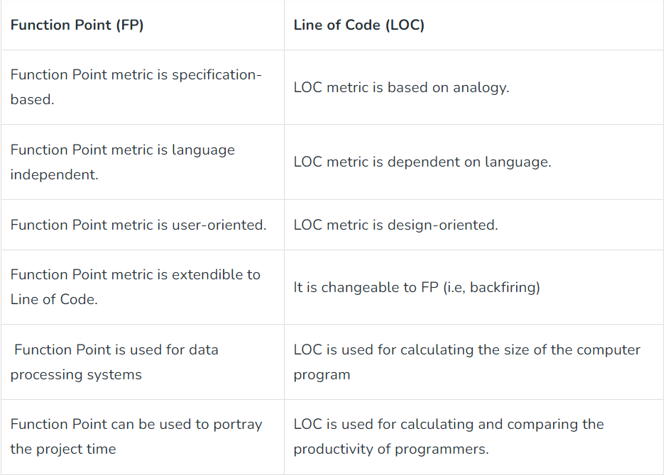

1. **What is the use of a use case diagram? Draw use case diagram diagram for hospital management system.**

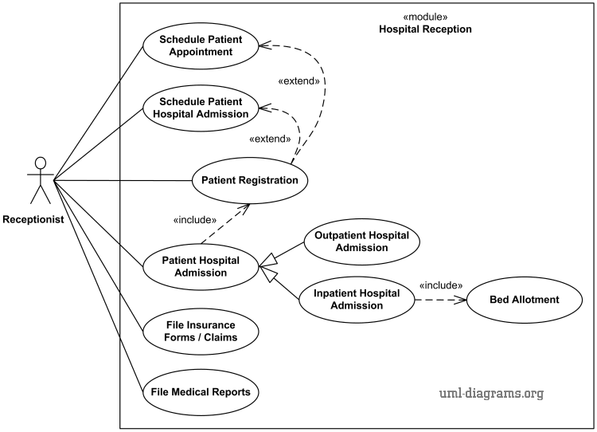

1. **Discuss functional and non-functional requirements**

Requirements:

A requirement is a written description of a characteristic or capability that a new or upgraded product design must incorporate. They are often quite detailed, and describe what must be provided, not how it is to be provided. In other words, they exclude implementation details. Requirements, and the documents they appear in, are legally binding so the language used for them is very specific. In particular, a requirement that must be provided includes the words shall, or will.

Functional Requirements:

In Software engineering and systems engineering, a functional requirement defines a function of a system or its component. A function is described as a set of inputs, the behavior,and outputs.

Functional requirements may be calculations,technical details,data manipulation and processing and other specific functionality that define what a system is supposed to accomplish.Behavioral requirements describing all the cases where the system uses the functional requirements are captured in use cases.

Generally, functional requirements are expressed in the form "system must do <requirement>", while non-functional requirements are "system shall be <requirement>".

The plan for implementing functional requirements is detailed in the system design. The plan for implementing non-functional requirements is detailed in the system architecture.

A typical functional requirement will contain a unique name and number, a brief summary, and a rationale. This information is used to help the reader understand why the requirement is needed, and to track the requirement through the development of the system.

The crux of the requirement is the description of the required behavior, which must be clear and readable. The described behavior may come from organizational or business rules, or it may be discovered through elicitation sessions with users, stakeholders, and other experts within the organization.

**Non-Functional Requirements:**

In systems engineering and requirements engineering, a non-functional requirement is a requirement that specifies criteria that can be used to judge the operation of a system, rather than specific behaviors. They are contrasted with functional requirements that define specific behavior or functions.

Non-functional requirements are often called "quality attributes" of a system. Other terms for non-functional requirements are "qualities","quality goals","quality of service requirements","constraints" and "non-behavioral requirements".

Qualities that is non-functional requirements can be divided into two main categories:

Execution qualities, such as security and usability, which are observable at run time.

Evolution qualities, such as testability, maintainability, extensibility and scalability, which are embodied in the static structure of the software system.

Examples

A system may be required to present the user with a display of the number of records in a database. This is a functional requirement. How up-to-date [update] this number needs to be, is a non-functional requirement. If the number needs to be updated in real time, the system architects must ensure that the system is capable of updating the [displayed] record count within an acceptably short interval of the number of records changing.

Sufficient network bandwidth may be a non-functional requirement of a system.

1. **What is functional point analysis, explain in detail? What are its benefits in the engineering process?**

Functional Point Analysis (FPA) is a software estimation technique used to measure the size and complexity of a software system. It is based on the principle that the size of a software system is directly proportional to the amount of functionality it provides to its users. FPA is used to estimate the effort required to develop, test, and maintain the software system.

FPA involves identifying and classifying the different functions that a software system provides to its users. These functions are classified into different categories based on their complexity and the effort required to implement them. The five main categories of functions are:

External Inputs (EI): These are the functions that allow the user to input data into the system. For example, entering customer details into a CRM system.

External Outputs (EO): These are the functions that allow the system to output data to the user. For example, generating a report or displaying data on a dashboard.

External Inquiries (EQ): These are the functions that allow the user to query the system for information. For example, searching for a particular product in an e-commerce website.

Internal Logical Files (ILF): These are the functions that store and manipulate data within the system. For example, storing customer information in a database.

External Interface Files (EIF): These are the functions that allow the system to exchange data with other systems. For example, importing data from an external source into the system.

Once the functions have been identified and classified, each function is assigned a complexity rating based on the number of data elements involved and the processing required. The complexity rating is used to calculate the function point count, which is used as a measure of the size and complexity of the software system.

The benefits of FPA in the software engineering process are numerous. Firstly, FPA provides a more accurate estimate of the size and complexity of a software system, which can help in planning and resource allocation. It also allows for more accurate cost estimation and can help in negotiating contracts with clients.

Additionally, FPA can help in identifying areas of the software system that are more complex and may require more attention during the development process. This can help in identifying potential risks and mitigating them before they become major issues.

Finally, FPA can be used to track progress during the development process and to monitor the overall quality of the software system. This can help in ensuring that the software system meets the requirements of the client and is delivered on time and within budge

1. **What are the objectives of requirement analysis?**

Software requirement means requirement that is needed by software to increase quality of software product. These requirements are generally a type of expectation of user from software product that is important and need to be fulfilled by software. Analysis means to examine something in an organized and specific manner to know complete details about it.

Therefore, Software requirement analysis simply means complete study, analyzing, describing software requirements so that requirements that are genuine and needed can be fulfilled to solve problem. There are several activities involved in analyzing Software requirements. Some of them are given below :

Problem Recognition :

The main aim of requirement analysis is to fully understand main objective of requirement that includes why it is needed, does it add value to product, will it be beneficial, does it increase quality of the project, does it will have any other effect. All these points are fully recognized in problem recognition so that requirements that are essential can be fulfilled to solve business problems.

Evaluation and Synthesis :

Evaluation means judgement about something whether it is worth or not and synthesis means to create or form something. Here are some tasks are given that is important in the evaluation and synthesis of software requirement :

To define all functions of software that necessary.

To define all data objects that are present externally and are easily observable.

To evaluate that flow of data is worth or not.

To fully understand overall behavior of system that means overall working of system.

To identify and discover constraints that are designed.

To define and establish character of system interface to fully understand how system interacts with two or more components or with one another.

Modeling :

After complete gathering of information from above tasks, functional and behavioral models are established after checking function and behavior of system using a domain model that also known as the conceptual model.

Specification :

The software requirement specification (SRS) which means to specify the requirement whether it is functional or non-functional should be developed.

Review :

After developing the SRS, it must be reviewed to check whether it can be improved or not and must be refined to make it better and increase the quality.

1. **Draw the Data Flow diagram up to level 2 for a restaurant management system which has online food ordering, food delivering, GST calculation, invoice creation, and payments subsystems.**

[**https://www.geeksforgeeks.org/dfd-for-food-ordering-system/**](https://www.geeksforgeeks.org/dfd-for-food-ordering-system/)

1. **Draw a complete use case for anyone of the following activities.**

**Buying a stock using an online brokerage account.**

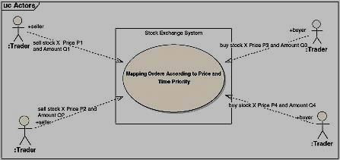

**Using your charge card for a meal at a restaurant.**

1. **Draw the state chart diagram and activity diagram for ATM system.**

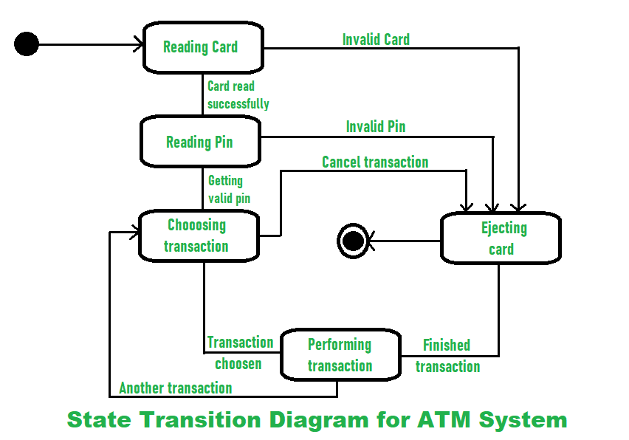

1. 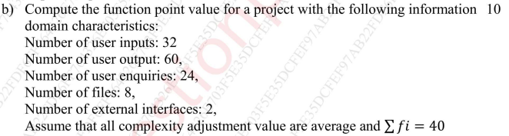
2. **List the principles of Software Design**

The design process should not suffer from ‘tunnel vision.’

The design should be traceable to the analysis model.

The design should not reinvent the wheel.

The design should “minimize the intellectual distance” between the software and the problem as it exists in the real world.

The design should exhibit uniformity and integration.

The design should be structured to accommodate change.

The design should be structured to degrade gently, even when aberrant data, events, or operating conditions are encountered.

Design is not coding, coding is not design.

The design should be assessed for quality as it is being created, not after the fact.

The design should be reviewed to minimize conceptual (semantic) errors.

.

1. **Explain Coupling and Cohesion.**

The “single-mindedness” of a module cohesion implies that a single component

or class encapsulates only attributes and operations that are closely related to one another and to the class or component itself.

Examples of cohesion

Functional: Typically applies to operations. Occurs when a

module performs one and only one computation

and then returns a result.

Layer: Applies to packages, components, and classes. Occurs when a higher layer

can access a lower layer, but lower layers do not access higher layers.

Communicational:

All operations that access the same data are

defined within one class.

In general, such classes focus solely on the

data in question, accessing and storing it.

Example: A StudentRecord class that adds,

removes, updates, and accesses various

fields of a student record for client

components.

**Coupling**

A qualitative measure of the degree to which classes or

components are connected to each other.

**Avoid:**

Content coupling:

Occurs when one

component

“surreptitiously modifies

data that is internal to

another component”

Violates information

hiding

**Use caution:**

Common coupling:

Occurs when a number of components all make

use of a global variable.

**Be aware:**

Routine call coupling:

Certain types of coupling occur routinely in

object-oriented programming.

Type use coupling

Inclusion or import coupling

1. **Explain different architectural styles.**

Architectural style describes a system category that

encompasses:

a set of components (e.g., a database, computational modules) that

perform a function required by a system,

a set of connectors that enable “communication, coordination, and

cooperation” among components, constraints that define how components can be integrated to form the system, and semantic models that enable a designer to understand the overall properties of a system.

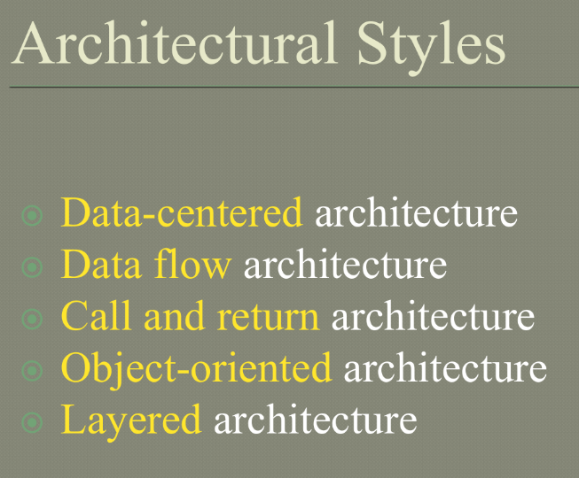

Data-centered architecture is a software architecture pattern that focuses on the storage, management, and access of data. In this architecture, data is considered the central component around which all other components are built.

In a data-centered architecture, data is stored in a central repository, such as a database, and all other components interact with the data through well-defined interfaces. The architecture is designed to ensure that data is accurate, consistent, and available to all components that need it.

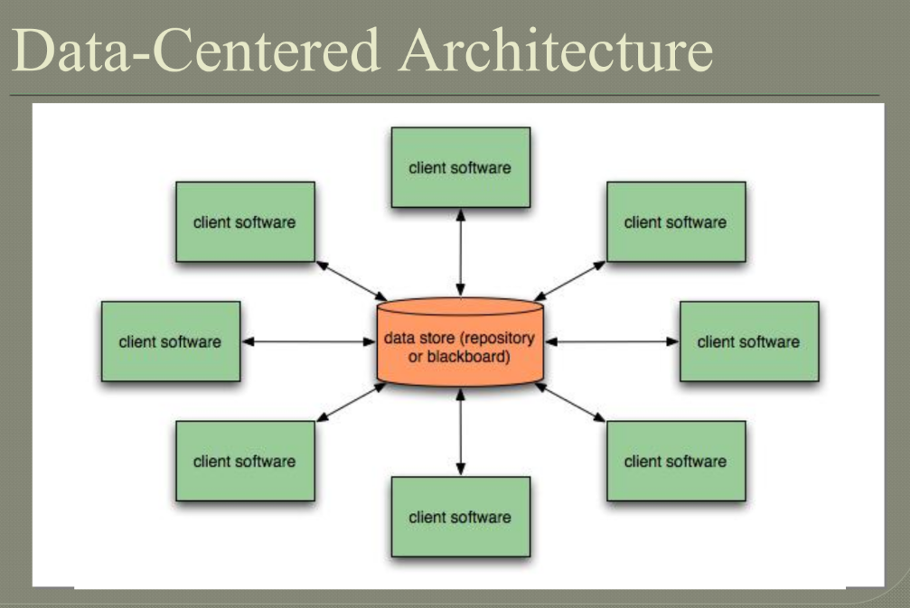

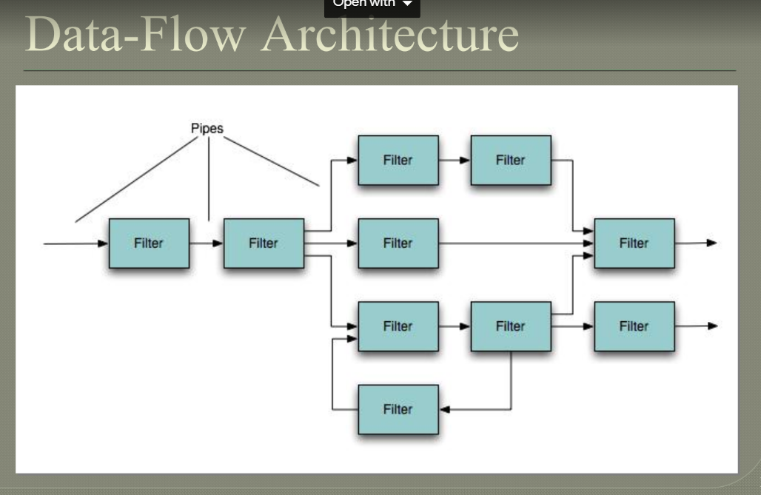

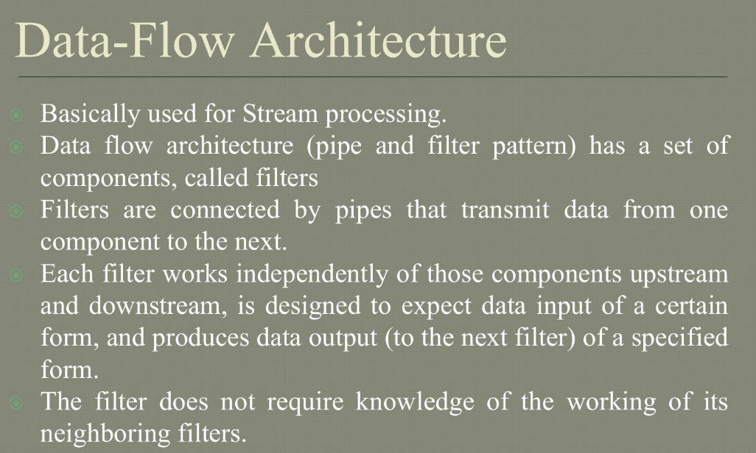

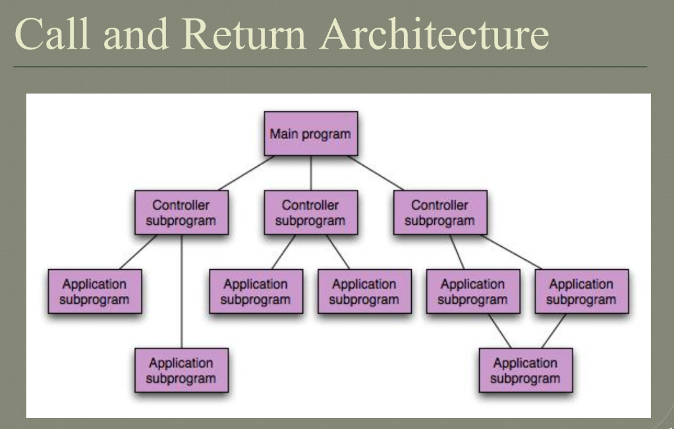

Call and return architecture, also known as subroutine architecture, is a design pattern commonly used in software engineering to structure programs into smaller, reusable components.

In call and return architecture, a program is divided into subroutines or procedures, each of which performs a specific task. When the program needs to perform that task, it "calls" the appropriate subroutine, passing any necessary parameters. The subroutine then executes its instructions and "returns" control back to the calling program.

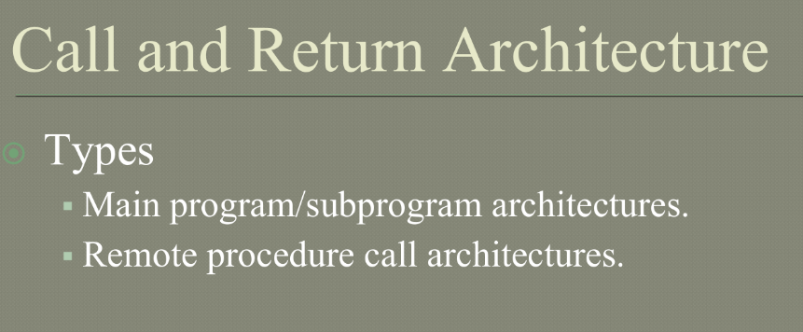

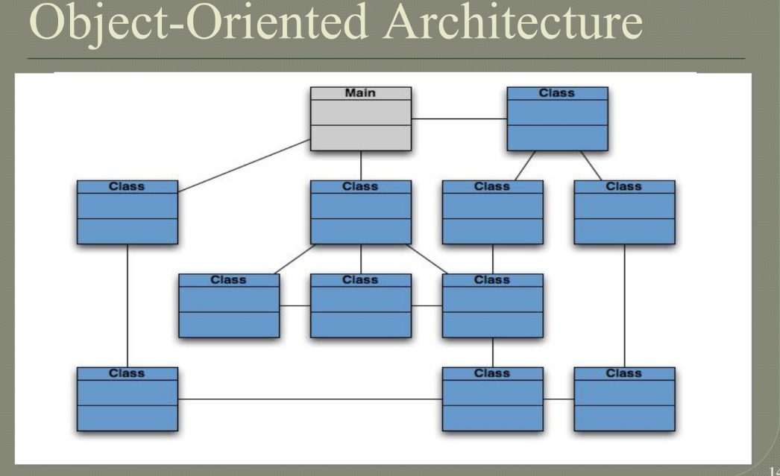

Object-oriented architecture is a design paradigm that is widely used in software engineering. It involves organizing software systems into a collection of objects that communicate with each other through messages.

In an object-oriented architecture, the system is organized into a collection of classes, which define the properties and behavior of objects. Objects are instances of classes, and communicate with each other through messages. The use of object-oriented architecture can promote modularity, flexibility, and code reuse, and is widely used in a variety of software applications.

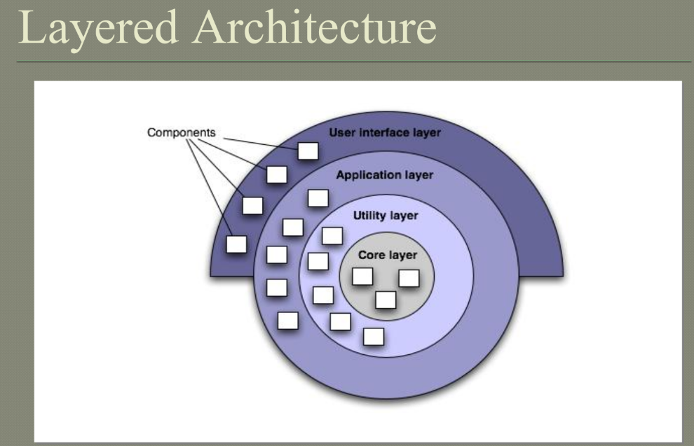

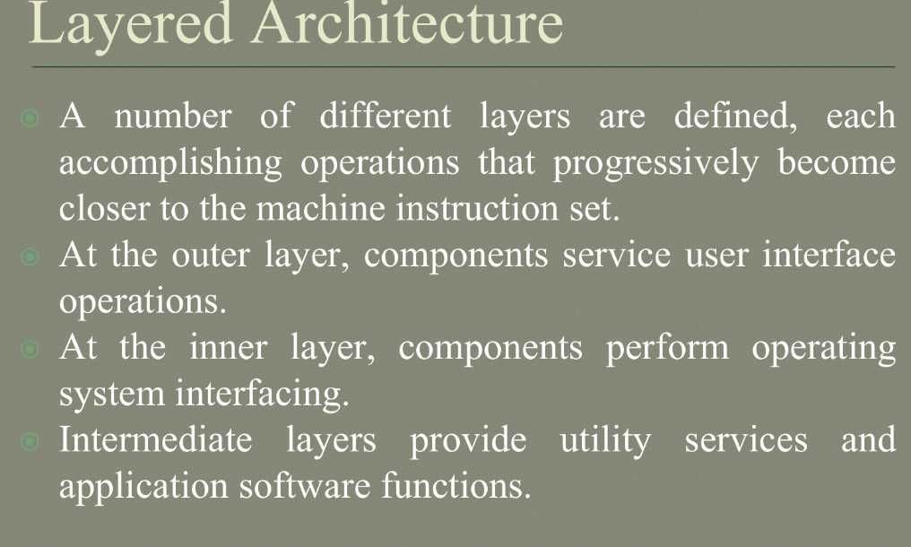

1. **Discuss about the principles of user interface design steps?**

Golden Rules

Place the user in control

Avoid unnecessary or undesired actions. spell checker, debug errors, showing an error message or a home page repeatedly etc.

Provide for flexible interaction. Keyboard, Mouse, Pen, Voice, Actions etc.

Allow user interaction to be interruptible and undoable.

Make sure – no loss of data already worked

Streamline interaction as skill levels advance and allow the interaction to be customized. Expert users, unattended workings, macros

Hide technical internals from the casual user.

Design for direct interaction with objects that appear

on the screen.

Give the user real world feel and sense of control.

Allow manipulation of objects on screen (stretch, skew,

rotation etc.)

Reduce the user’s memory load

Principles :

Reduce demand on short-term memory.

Establish meaningful defaults.

Define shortcuts that are intuitive.

The visual layout of the interface should be based on a real world metaphor.

Disclose information in a progressive (Hierarchical) fashion.

Make the interface consistent

All visual information should be organized according to a design standard that is maintained throughout all screen displays.

Input mechanisms should be constrained to a limited set that are used consistently throughout the application.

Mechanisms for navigating from task to task should be consistently defined and implemented.

1. **What are the benefits of high cohesion and low coupling?**

High cohesion and low coupling are important design principles in software engineering. The benefits of these principles are as follows:

**High cohesion**: High cohesion refers to the degree to which elements within a module or component are related to each other. When a module or component has high cohesion, it means that its elements are tightly related and work together to achieve a single, well-defined purpose.

**Benefits of high cohesion include:**

**Improved maintainability:** Modules or components with high cohesion are easier to maintain because they have clear and well-defined responsibilities.

Increased reusability: High cohesion allows for greater reusability of code, as well-designed modules or components can be easily adapted and reused in other projects or parts of the same project.

Reduced complexity: High cohesion reduces the complexity of the code, as each module or component has a clear and distinct purpose.

Low coupling: Low coupling refers to the degree to which modules or components are dependent on each other. When modules or components have low coupling, it means that they are independent of each other and can be changed or modified without affecting other parts of the system. Benefits of low coupling include:

Improved maintainability: Low coupling makes it easier to maintain code, as changes to one module or component are less likely to have an impact on other modules or components.

Increased flexibility: Low coupling allows for greater flexibility in the design and implementation of a system, as each module or component can be modified or replaced without affecting other parts of the system.

Reduced complexity: Low coupling reduces the complexity of the code, as each module or component has a limited set of dependencies and can be understood and modified more easily

1. **Illustrate Design Principles.**

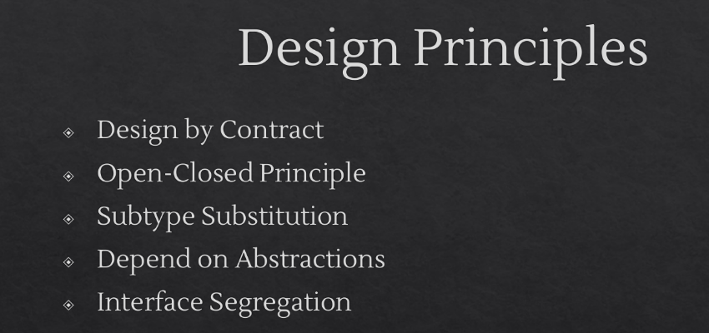

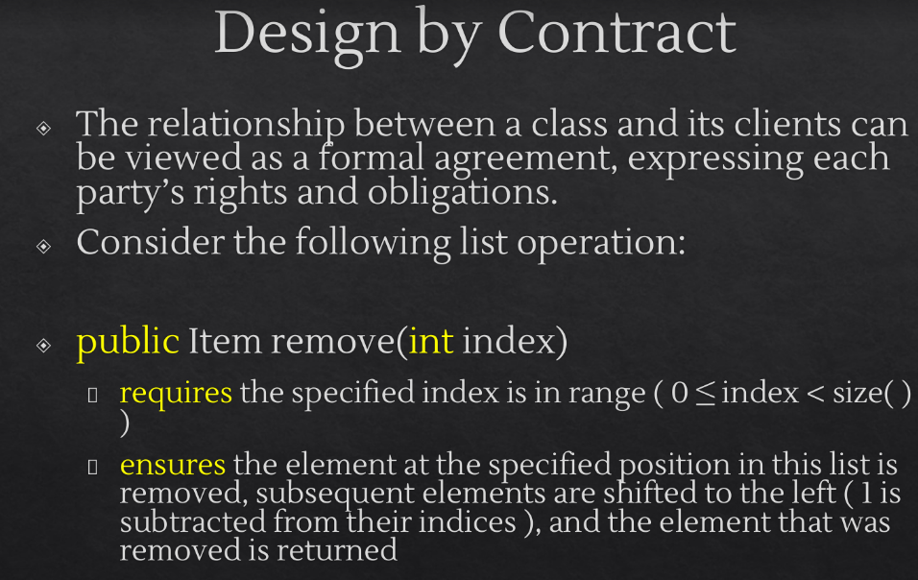

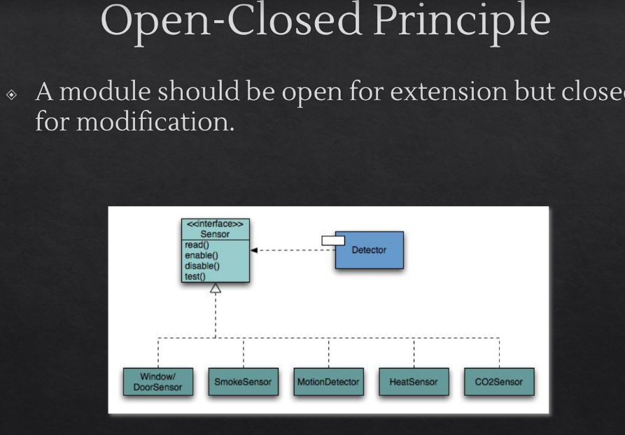

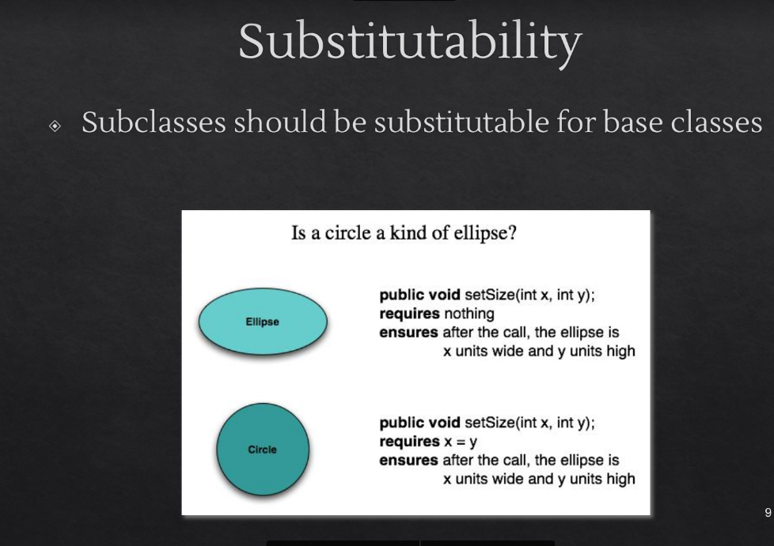

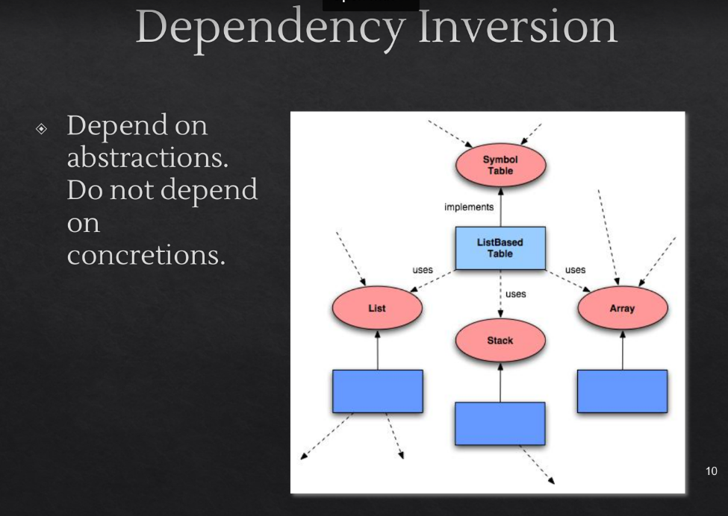

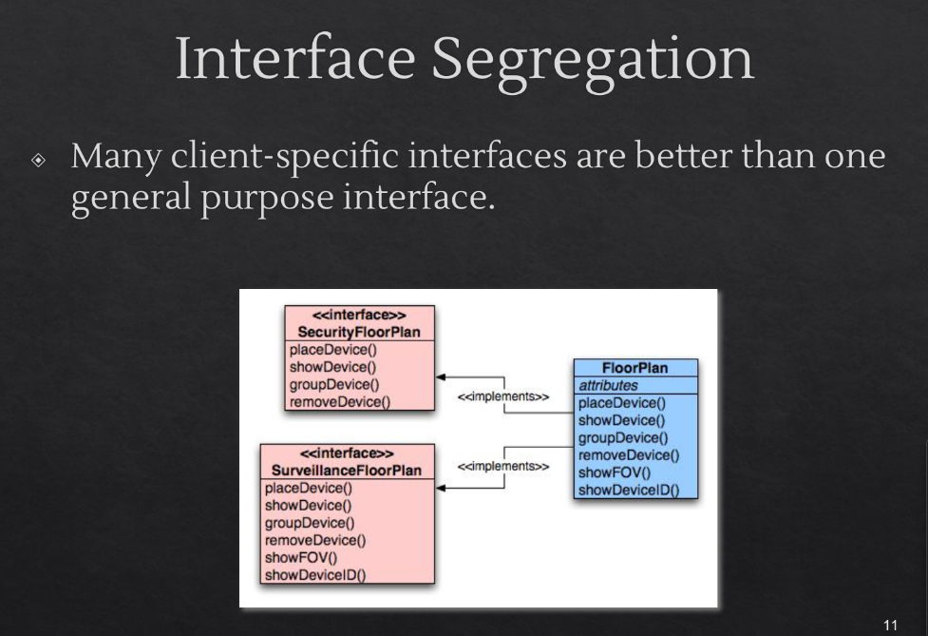

1. **Illustrate design issues.**

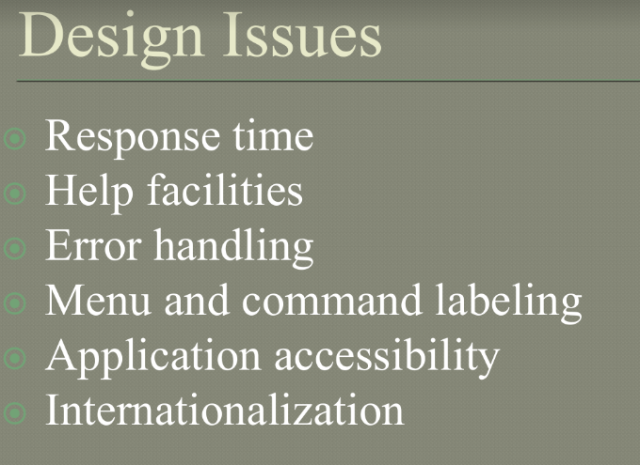

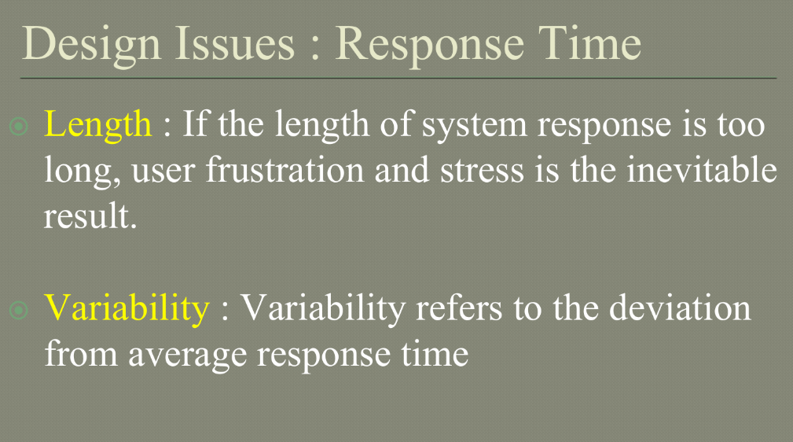

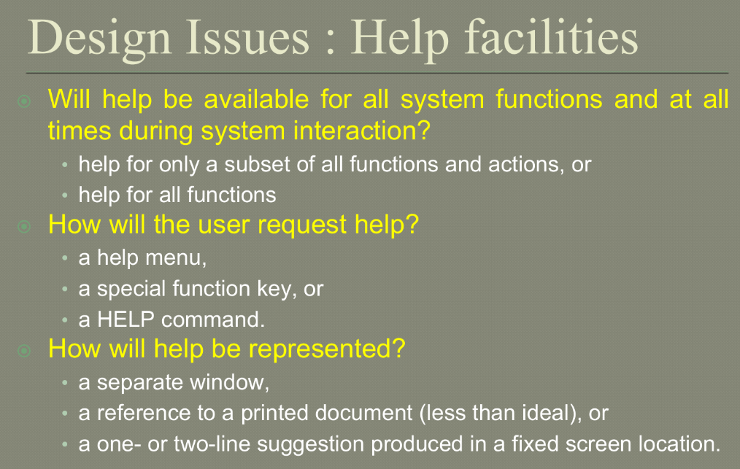

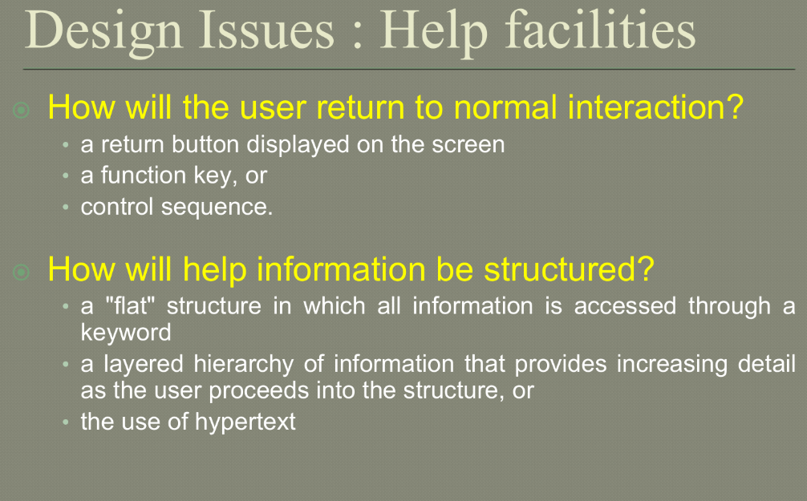

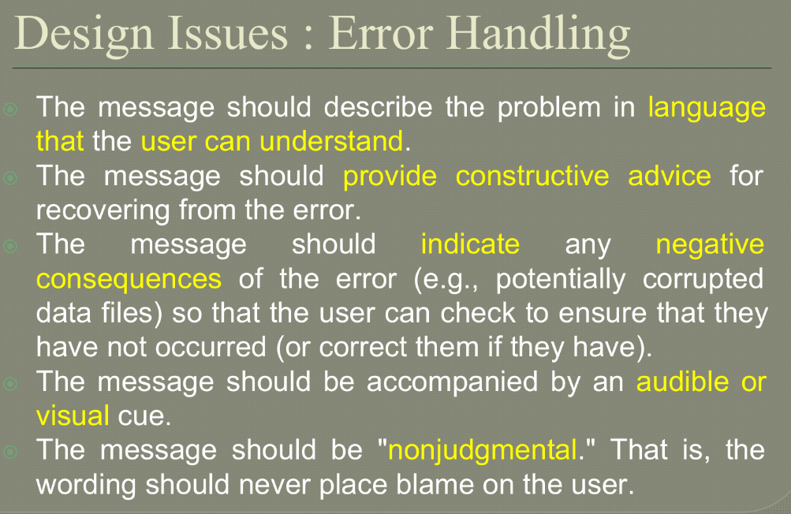

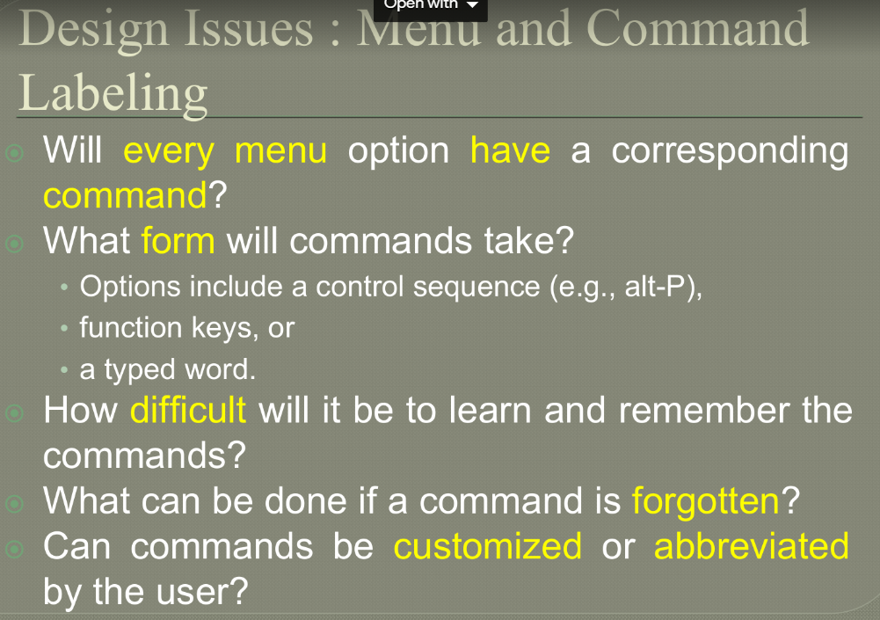

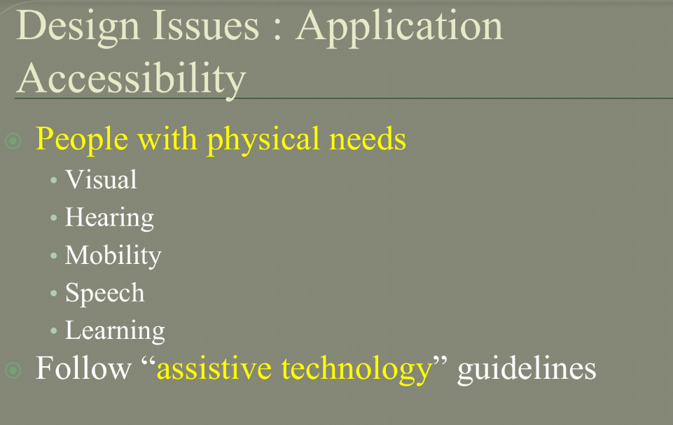

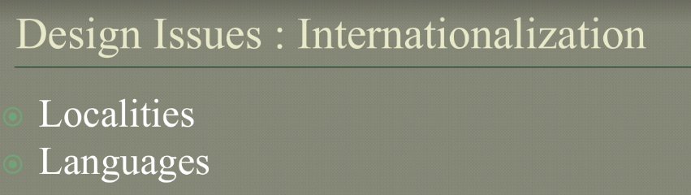

1. **Explain how an analysis model is translated to Design models. Explain in detail the design quality guidelines and attributes.**

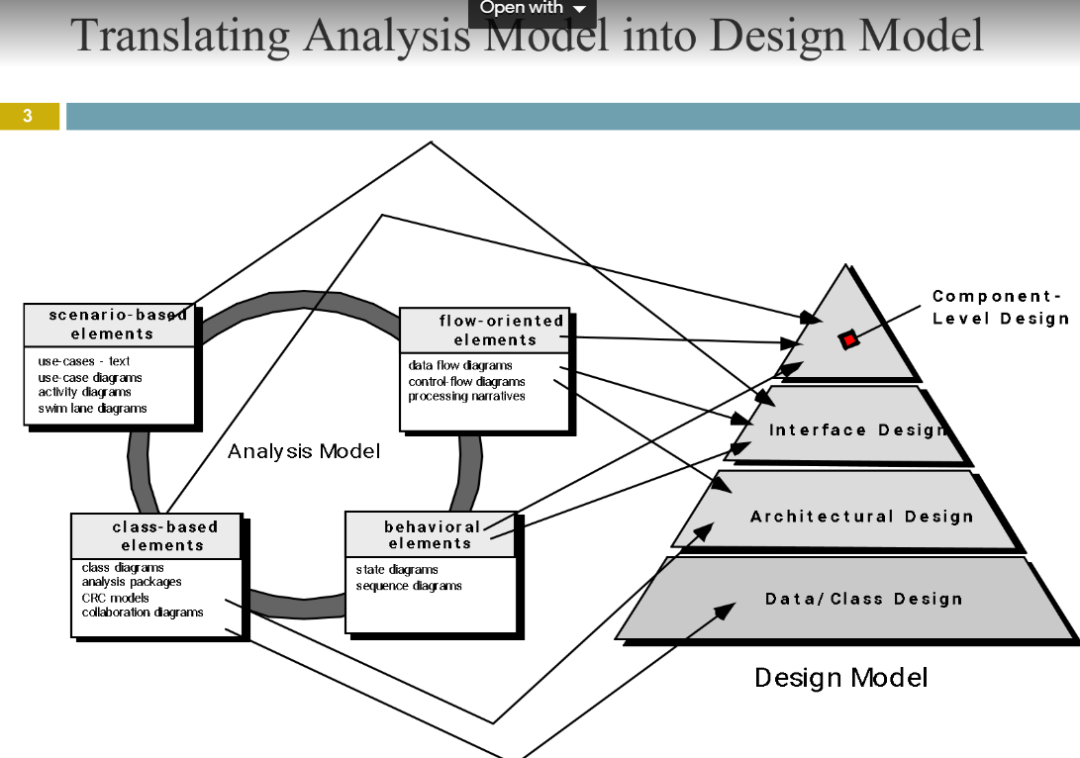

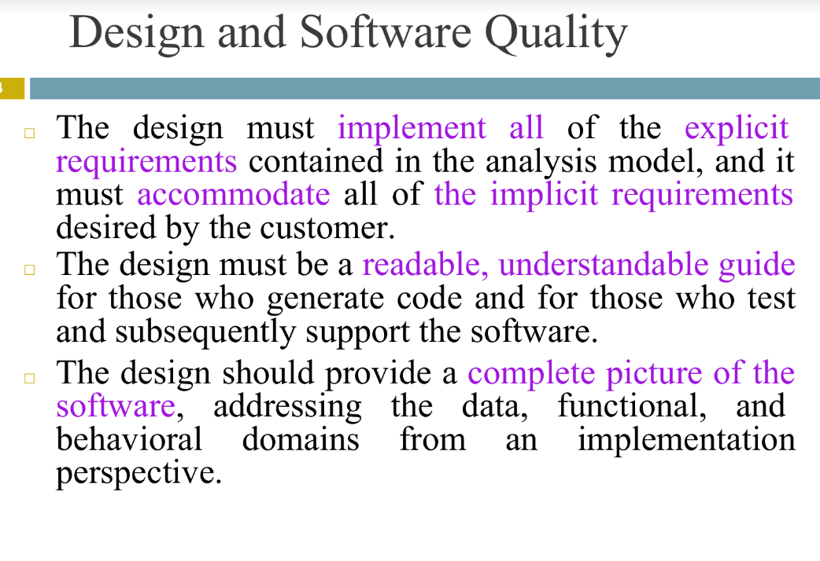

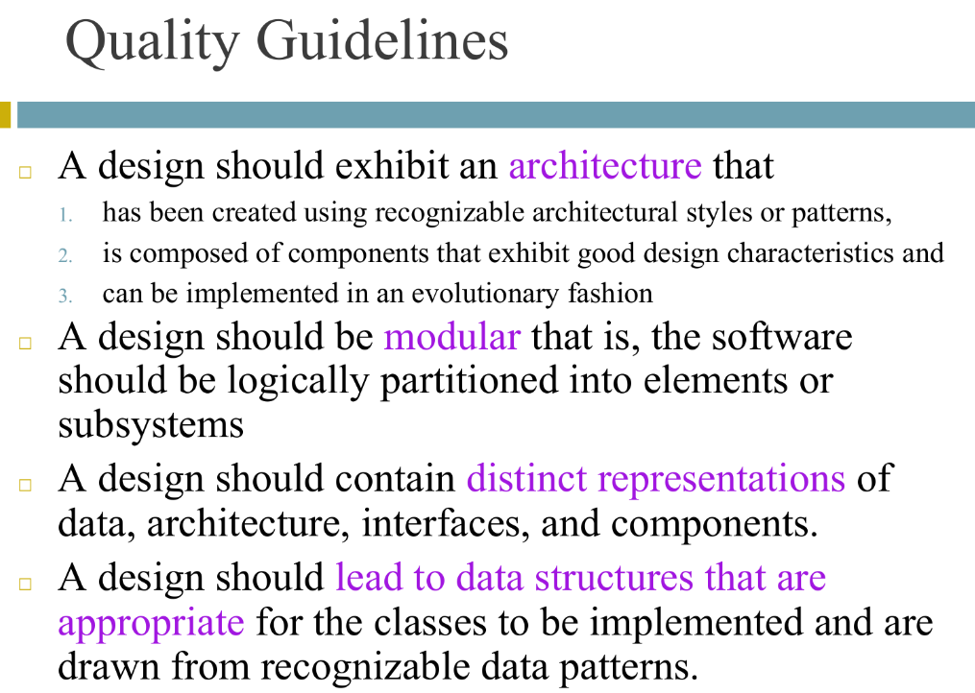

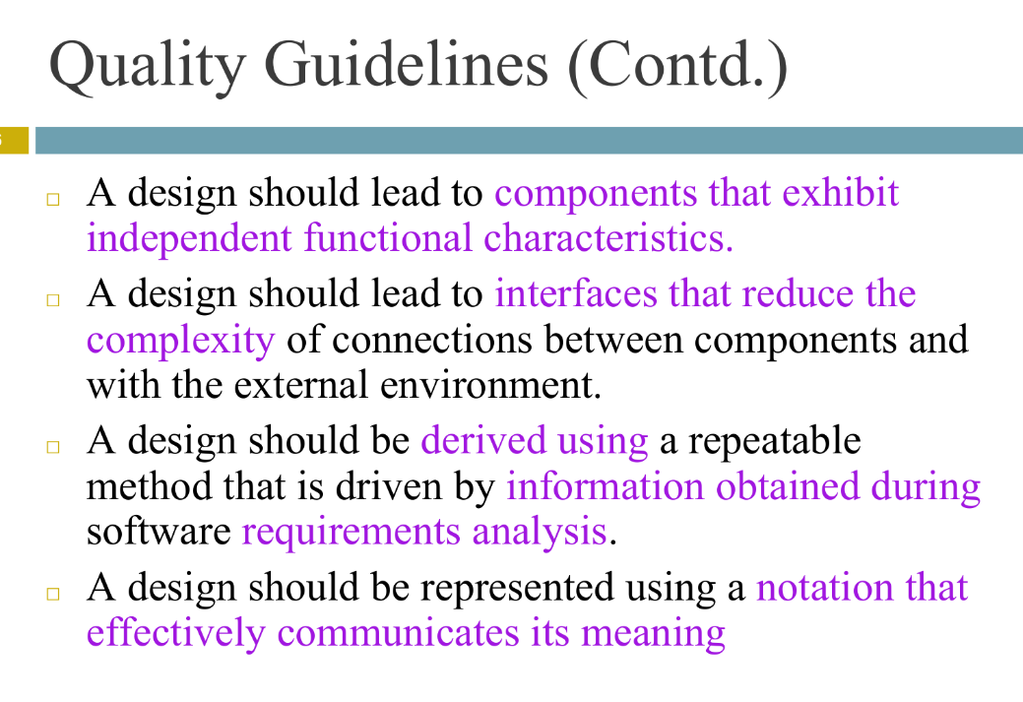

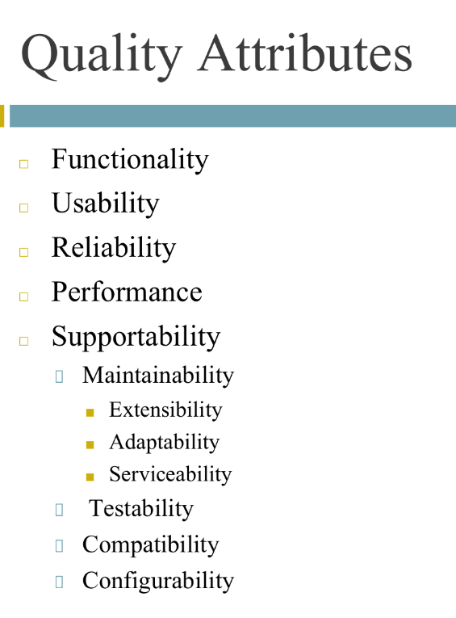

1. **What are the benefits of component based development model? With a neat diagram and explain the different phases of component based development.**

Component-based development (CBD) is a software development model that emphasizes the construction of software systems from reusable, interchangeable software components. The goal of CBD is to reduce development time and costs by using pre-existing software components to build new systems.

In CBD, software components are independent modules or units that can be assembled to create complex systems. These components are typically self-contained and have well-defined interfaces, which allow them to be easily integrated into larger software systems. Components can be developed in different programming languages, and they can be distributed across different platforms and environments.

The CBD model typically involves the following phases:

Component identification: In this phase, the software components that will be used in the development of the new system are identified. These components may be obtained from third-party libraries, open-source projects, or developed in-house. The focus is on identifying components that can be reused across different systems, rather than building everything from scratch.

Component specification: In this phase, the identified components are analyzed to determine their functionality and how they can be integrated into the new system. This involves documenting the requirements, interfaces, and dependencies of each component.

Component design: In this phase, the components are designed and developed according to the specifications documented in the previous phase. The focus is on creating components that are modular, reusable, and maintainable.

Component implementation: In this phase, the components are implemented and tested individually to ensure that they meet the specifications and requirements documented in the earlier phases. This involves coding, debugging, and testing each component.

Component assembly: In this phase, the components are integrated into the new system. The focus is on ensuring that the components work together as expected and that the overall system meets the requirements.

Component testing: In this phase, the system is tested to ensure that it works as expected. This testing involves testing the system as a whole, as well as each individual component.

Component maintenance: Once the system is deployed, the components may need to be updated or replaced. Component maintenance involves identifying and fixing any issues or bugs in the components and updating them to ensure that they remain compatible with the overall system.

The main benefits of Component-Based Development (CBD):

1. Reusability of software components
2. Faster development times and lower development costs
3. Scalability through modular systems
4. Easier maintenance through the use of standard components and independent development
5. Reduced development costs through component reuse
6. Improved quality of software systems
7. Interoperability through the use of standard interfaces and protocols
8. **Discuss different categories of risk that help to define impact values in a risk table.**

A risk table is a common tool used in risk management to assess and prioritize risks based on their likelihood and potential impact. In order to define impact values in a risk table, it is helpful to consider different categories of risk. Here are some examples:

Financial risk: Financial risks relate to the potential monetary loss that an organization might incur due to a particular risk. For example, if there is a risk of a product recall due to safety concerns, the financial impact could include costs associated with the recall, lost sales, and damage to the company's reputation.

Operational risk: Operational risks are those that affect an organization's ability to conduct its day-to-day operations. These could include risks related to equipment failure, supply chain disruptions, or IT system outages. The impact of these risks could include downtime, lost productivity, and decreased efficiency.

Legal and regulatory risk: Legal and regulatory risks are those that arise from the potential violation of laws or regulations. These risks could include fines, penalties, legal fees, or damage to the organization's reputation.

Reputational risk: Reputational risks relate to the potential damage to an organization's reputation. These risks could arise from a wide range of factors, including product recalls, data breaches, or ethical violations. The impact of reputational risks can be difficult to quantify, but they can have long-lasting effects on the organization's ability to attract and retain customers.

Strategic risk: Strategic risks relate to the potential impact on an organization's long-term strategy or goals. These risks could arise from changes in the market, competitive pressures, or shifts in consumer preferences. The impact of strategic risks could include lost market share, decreased profitability, or the need for a major strategic shift.

By considering these different categories of risk, organizations can develop a more comprehensive understanding of the potential impact of a particular risk. This can help them to prioritize their risk management efforts and allocate resources more effectively.

1. **Illustrate change control and version control.**

Software configuration management (SCM) is a software engineering discipline consisting of standard processes and techniques often used by organizations to manage the changes introduced to its software products. SCM helps in identifying individual elements and configurations, tracking changes, and version selection.

SCM is also known as software control management. SCM aims to control changes introduced to large complex software systems through reliable version selection and version control.

Version Control:-

Software Version Control is a system or tool that captures the changes to a source code elements: files, folders, images or binaries.

A version control system (also known as a Revision Control System) is a repository of files, often the files for the source code of computer programs, with monitored access. Every change made to the source is tracked, along with who made the change, why they made it, and references to problems fixed, or enhancements introduced, by the change.

Version control systems are essential for any form of distributed, collaborative development. Whether it is the history of a wiki page or large software development project, the ability to track each change as it was made, and to reverse changes when necessary can make all the difference between a well managed and controlled process and an uncontrolled ‘first come, first served’ system. It can also serve as a mechanism for due diligence for software projects.

• Combines procedures and tools to manage the different versions of configuration objects created during the software process.

• Version control systems require the following capabilities.

o Project repository – stores all relevant configuration objects.

o Version management capability – stores all versions of a configuration object (enables any version to be built from past versions)

o Make facility – enables collection of all relevant configuration objects and construct a specific software version.

o Issues (bug) tracking capability – enables team to record and track status of outstanding issues for each configuration object.

• Uses a system modeling approach (template – includes component hierarchy and component build order, construction rules, verification rules).

Change Control:-

Change control is a systematic approach to managing all changes made to a product or system. The purpose is to ensure that no unnecessary changes are made, that all changes are documented, that services are not unnecessarily disrupted and that resources are used efficiently.

Here's an example of a six-step process for a software change request:

Documenting the change request:

When the client requests the change, that request is categorized and recorded, along with informal assessments of the importance of that change and the difficulty of implementing it.

Formal assessment:

The justification for the change and risks and benefits of making/not making the change are evaluated. If the change request is accepted, a development team will be assigned. If the change request is rejected, that fact is documented and communicated to the client.

Planning:

The team responsible for the change creates a detailed plan for its design and implementation, as well as a plan for rolling back the change should it be deemed unsuccessful.

Designing and testing:

The team designs the program for the software change and tests it. If the change is deemed successful, the team requests approval and a date for implementation.

Implementation and review:

The team implements the program and stakeholders review the change.

Final assessment:

If the client is satisfied that the change was implemented satisfactorily, the change request is closed. If the client is not satisfied, the project is reassessed and steps may be repeated.

1. **What is Change Control? How it is different from version control.**

Change Control is a process used in project management to manage changes to a project's scope, schedule, budget, and other key aspects. It involves a systematic approach to reviewing, evaluating, and approving or rejecting changes to ensure that they are aligned with the project goals and objectives. Change Control helps to prevent unapproved changes that could negatively impact project outcomes.

On the other hand, version control is a process used in software development to manage changes to source code and other artifacts. It involves a systematic approach to tracking changes, managing versions, and collaborating with team members to ensure that code changes are integrated smoothly and efficiently.

The main difference between Change Control and version control is that Change Control is focused on managing changes to the project's scope, schedule, budget, and other aspects, while version control is focused on managing changes to the source code and other artifacts. Change Control involves a broader range of stakeholders and a more comprehensive review process, while version control is primarily focused on developers and code changes.

In summary, Change Control and version control are two distinct processes that serve different purposes in project management and software development. While both involve managing changes, they are focused on different aspects of a project or software development effort.

1. **Explain Software configuration process.**

Software Configuration Management (SCM)

Change Management, or more commonly called as Software Configuration Management (SCM), is an activity that is applied throughout the software process.

Because change can occur at any time, SCM Activities are developed to :

Identify changes

Change control

Ensure that changes are being properly implemented

Report changes to others who may have interest.

Five Major Tasks in Software Configuration Management:

Following are the five major tasks involved in SCM Process

Identification of Objects in the Software Configuration:

To control and manage software configuration items, each should be separately named and then organized using an object oriented approach.

Two types of objects can be identified : Basic objects and aggregate objects

A basic object is a unit of information that has been created by a software engineer during analysis, design, code or test. For example, a basic object might be a section of requirements specification, part of design model or a source code of component.

An aggregate object is a collection of basic objects. Each object has a set of distinct features that identify it uniquely: a name, a description, a list of resources.

Configuration object identification can also consider the relationships that exist between named objects. For example, using the simple notation :

Class diagram <part-of> analysis model;

Analysis model <part-of> requirements specification;

Version Control:

Version control combines procedures and tools to manage different versions of configuration objects that are created during the software process.

A version control system implements or is directly integrated with four major capabilities:

A project database (repository) that stores all relevant configuration objects

A version management capability that stores all versions of configuration object.

A make facility that enables the software engineer to collect all relevant configuration objects and construct a specific version of the software.

In addition, version control and change control systems often implement an issue tracking (also called as bug tracking) capability that enables the team to record and track the status of all outstanding issues associated with each configuration object.

A number of version control systems establish a change set - a collection of all changes (to some baseline configuration) that are required to create a specific version of the software.

A change set captures all changes to all files in the configuration along with the reason for the changes and details of who made the changes and when.

A number of named change sets can be identified for an application or system. A number of different automated approaches to version control have been proposed over the last two decades.

Change Control

In a change control process, a change request is submitted and evaluated to assess technical merit, potential side effects, overall impact on other configuration objects and system functions and the projected cost of change.

The results of evaluation are presented as a change report, which is used by a change control authority (CCA) – a person or a group who makes the final decision on the status and priority of the change.

An Engineering Change Order (ECO) is generated for each approved change. The ECO describes the change to be made, the constraints that must be respected and the criteria for review and audit.

A version control system updates the original file once the change has been made. As an alternative, the objects can be checked out of the project database, the change is made and appropriate SQA activities are applied. The object is then checked into the database and appropriate version control mechanisms are used to create the next version of the software.

These version control mechanisms, integrated within the change control process, implement two important elements of change management – access control and synchronization.

Access control governs which software engineers have authority to access and modify a particular configuration object.

Synchronization control helps to ensure that parallel changes, performed by two different people do not overwrite one another.

Configuration Audit

A software configuration audit complements the formal technical review by addressing the following questions:

Has the change specified in the ECO been made? Have any additional modifications been incorporated?

Has a formal technical review been conducted to assess technical correctness?

Has the software process been followed, and have software engineering standards been properly applied?

Has the change been highlighted in SCI? Have the change date and change author been specified? Do the attributes of the configuration object reflect the change?

Have SCM procedures for noting the change, recording it, and reporting it been followed?

Have all the Software Configuration Items been properly updated? Such formal configuration audits also ensure that the correct SCI’s have been incorporated into a specific build and that all the documentation is up to date and consistent with the version that has been built.

Status Reporting

Configuration status reporting is a SCM Task that answers the following questions

What happened?

Who did it?

When did it happen?

What else will be affected?

Each time a SCI is assigned new or updated identification, a configuration status reporting (CSR) entry is made.

Each time a change is approved by the CCA, a CSR entry is made. Each time a configuration audit is conducted, the results are reported as a part of CSR task.

Output from CSR can be placed in an online database or website, so that software developers can access change information by keyword category.

In addition CSR Report is generated on a regular basis and is intended to keep management and practitioners appraised of important changes.

1. **Explain Software Quality Assurance.**

Software Quality Assurance

Software quality assurance (SQA) is a process that ensures that developed software meets and complies with defined or standardized quality specifications.

SQA is an ongoing process within the software development life cycle (SDLC) that routinely checks the developed software to ensure it meets desired quality measures.

Rather than checking for quality after completion, SQA processes tests for quality in each phase of development until the software is complete. With SQA, the software development process moves into the next phase only once the current/previous phase complies with the required quality standards.

SQA generally works on one or more industry standards that help in building software quality guidelines and implementation strategies. These standards include the ISO 9000 and capability maturity model integration (CMMI).

SQA Activities:

Software quality assurance is composed of a variety of tasks associated with two different constituencies – the software engineers who do technical work and an SQA group that has responsibility for quality assurance planning, record keeping, analysis and reporting.

Following activities are performed by an independent SQA group:

1. Prepares an SQA plan for a project: The plan is developed during project planning and is reviewed by all stakeholders. Quality assurance activities performed by the software engineering team and the SQA group are governed by the plan. The plan identifies evaluations to be performed, audits and reviews to be performed, standards that are applicable to the project, procedures for error reporting and tracking, documents to be produced by the SQA team, and amount of feedback provided to the software project team.

2. Participates in the development of the project’s software process description: The software team selects a process for the work to be performed. The SQA group reviews the process description for compliance with organizational policy, internal software standards, externally imposed standards (eg. ISO-9001), and other parts of software project plan.

3. Reviews software engineering activities to verify compliance with the defined software process: The SQA group identifies, documents, and tracks deviations from the process and verifies that corrections have been made.

4. Audits designated software work products to verify compliance with those defined as a part of the software process : The SQA group reviews selected work products, identifies, documents and tracks deviations, verifies that corrections have been made, and periodically reports the results of its work to the project manager.

5. Ensures that deviations in software work and work products are documented and handled according to a documented procedure: Deviations may be encountered in the project plan, process description, applicable standards, or technical work products.

6. Records any noncompliance and reports to senior management: Non- compliance items are tracked until they are resolved.

Goals and Objectives of SQA:

Software Quality Assurance was created with the following objectives:

Small to Zero Defects after Installation – One of the biggest goals of SQA is to prevent any possible defects when the output is made. Developers and engineers have to use universally approved steps to ensure that the program was built up to expectations but also to prevent errors in the system. Although some standards allow as much as .04 errors in the system, zero-error is still the system’s target. When there’s zero-error, the program is more likely to have zero crash scenarios. The ability to handle stress of a program is different from the errors it has but crashes usually comes from defects so prevention of defects will most likely yield a continuously working application.

Customer Satisfaction – Everything else will be just nothing if the customers don’t like what they see. Part of SQA is to ensure that software development was made according to their needs, wants and exceeding their expectations. Even if the bugs and errors are minimized by the system, customer satisfaction is more important and should be emphasized.

Well Structured – SQA takes care of the stages of application construction. Anyone could be easily build an application and launch it in their environment without any glitches. However, not everyone could easily build an application that could be understood well. SQA ensures that each application are built in an understandable manner. Their applications could easily be transferred from one developer to another.

1. **Explain Risk Assessment and risk projection.**

Risk assessment is the process of identifying, evaluating, and prioritizing risks that may impact a software project. It is an important activity in software development that helps teams identify potential problems and develop strategies to mitigate or avoid them. Risk assessment involves several steps, including:

Risk identification: This involves identifying potential risks that may affect the software project. Risks may arise from various sources such as technical issues, human errors, or external factors.

Risk analysis: This involves assessing the likelihood and impact of each identified risk. This helps prioritize risks and determine which ones require immediate attention.

Risk evaluation: This involves evaluating the overall risk exposure of the software project. This is done by combining the likelihood and impact of all identified risks to determine the overall risk exposure.

Risk mitigation: This involves developing strategies to mitigate or eliminate identified risks. This may involve changing project plans, implementing additional controls, or taking other steps to reduce risk exposure.

Risk projection is the process of forecasting potential risks that may impact a software project in the future. It involves analyzing historical data, identifying trends, and making predictions about future risks. Risk projection is useful for identifying potential risks that may arise in the future and developing strategies to mitigate them before they occur.

To perform risk projection, a team may use various techniques such as statistical analysis, trend analysis, or scenario planning. Statistical analysis involves analyzing historical data to identify patterns and trends that may help predict future risks. Trend analysis involves analyzing current trends in the industry or market to identify potential future risks. Scenario planning involves creating hypothetical scenarios to test how the software project may respond to various potential risks.

In summary, risk assessment and risk projection are both important activities in software development that help teams identify potential risks and develop strategies to mitigate them. Risk assessment focuses on identifying, evaluating, and prioritizing risks that may impact a software project, while risk projection involves forecasting potential risks that may arise in the future.

1. **What are the different steps to determine the overall consequences of risks?**

Determining the overall consequences of risks involves a systematic approach to assessing the likelihood and impact of risks and developing a plan to mitigate or manage them.

**Step 1: Risk** Identification · **Step** 2: **Risk** Assessment · **Step** 3: **Risk** Treatment · **Step** 4: **Risk** Monitoring and Reporting.The following are the different steps involved in determining the overall consequences of risks:

Identify Risks: The first step is to identify all potential risks that could impact the project. This can be done through brainstorming sessions, risk assessment workshops, and other techniques.

Assess Likelihood: Once the risks have been identified, the next step is to assess the likelihood of each risk occurring. This can be done using techniques such as probability analysis, expert judgment, and historical data analysis.

Assess Impact: The next step is to assess the potential impact of each risk on the project. This can be done using techniques such as impact analysis, stakeholder analysis, and scenario planning.

Determine Overall Risk: Once the likelihood and impact of each risk have been assessed, the overall risk level can be determined. This can be done using a risk matrix or other similar tools that combine the likelihood and impact of each risk.

Develop Risk Response Plan: Based on the overall risk level, a risk response plan can be developed. This plan should identify strategies to mitigate or manage the risks, such as avoiding the risk, transferring the risk, reducing the risk, or accepting the risk.

Implement and Monitor: The final step is to implement the risk response plan and monitor the risks throughout the project lifecycle. This involves tracking the risks, monitoring their likelihood and impact, and adjusting the risk response plan as necessary.

In summary, determining the overall consequences of risks involves a structured approach to assessing the likelihood and impact of risks and developing a plan to mitigate or manage them. By following these steps, project managers can minimize the potential impact of risks on their projects and ensure successful outcomes.

1. **Explain the different metrics used for software quality and reliability.**

Quality Metrics

The goal of software engineering is to produce high quality software. To achieve this goal software engineers use effective methods along with modern tools while developing the software. Simply producing the software in this manner is not sufficient, it is necessary to measure the quality of software being software. Basically the quality of software depends upon-

Requirements that describe the problem

The design method used to produce the software

The code that leads to executable program

And the tests that are carried out in order to uncover the errors from the software.

The project manager evaluates the quality of the software project using following factors-

Errors and defects in the software

Quality metrics collected by each software engineer who is involved in the software development process.

Such an evaluation of software quality helps in improving quality assurance and control activities. Typically following metrics are used for software quality-

Work product errors per function

Errors found in the per review hour

Errors found in the testing

This error data is useful in computing the defect removal efficiency. Let us discuss the concept of defect removal efficiency (DRE) and Measuring Quality of software.

1) Measuring Quality

There are many measures of software quality Correctness, Integrity, Usability and Maintainability provide useful indicators to project team

Following are the measure of software quality –

I) Correctness :

Correctness is a degree to which the software produces the desired functionality. The correctness can be measured as

Correctness = Defects per KLOC

Where defects means lack of conformance to requirements. Such defects are generally reported by the user of the program.

II) Integrity:

Integrity is basically an ability of the system to withstand against the attacks. Typically attacks are on programs, data and documents.

There are two attributes that are associated with integrity: threat and security.

Threat is the probability that specific types of attacks may occur.

Security is the probability that the system will repel against the specific attacks.

Integrity can be measure as:

Integrity = ∑ ((1-threat) * (1-security))

III) Usability :

Usability means user friendliness of the system or ability of the system that indicates the usefulness of the system.

Following are the characteristics that are useful for measuring the usability. The user friendliness is measured using following four characteristics –

a) The time required to make the system efficient

b) The skill required to learn the system

c) The net increase in productivity after regular use of the system

d) The user attitude towards the system.

IV) Maintainability :

Maintainability is the ability of the system to accommodate the corrections made after encountering errors, adapting the environment and adapt the changes made in the system in order to satisfy the user.

The metric used for maintainability is MTTC i.e. Mean Time to Change. The MTTC can be defined as the time required to analyse the change request, design an appropriate modification and implementation of those desired changes.

Lower the value of MTTC means the software is more maintainable.

2) Defect Removal Efficiency (DRE)

While developing the software project many work products such as SRS, design document, source code are being created. Along with these work products many errors may get generated. Project manager has to identify all these errors to bring quality software.

Error tracking is a process of assessing the status of the software project.

The software team performs the formal technical reviews to test the software developed. In this review various errors are identified and corrected. Any errors that remain uncovered and are found in later are called defects.

The defects removal efficiency can be defined as:

DRE = E/(E+D)

Where DRE is the defect removal efficiency,

E is the error and

D is defect.

The DRE represents the effectiveness of quality assurance activities. The DRE also helps the project manager to assess the progress of software project as it gets developed through its scheduled work task.

During error tracking activity following metrics are computed

Errors per requirement specification page : denoted by Ereq

Errors per component – design level : denoted by Edesign

Errors per component – code level : denoted by Ecode

DRE – requirement analysis

DRE – architectural design

DRE – component level design

DRE – coding

The project manager calculates current values for Ereq,Edesign,Ecode

. These values are then compared with past projects. If the current differs more than 20 % from the average, then there may be cause for concern and investigation needs to be made in this regard.

These error tracking metrics can also be used for better target review and testing resources.

1. **Explain the various steps involved in change control.**

Change control is the process of managing changes to a software project. It involves several steps to ensure that changes are properly evaluated, approved, and implemented. The following are the typical steps involved in change control:

Change identification: The first step is to identify the need for a change. This may involve identifying problems, issues, or opportunities that require changes to the software project.

Change request: Once the need for a change has been identified, a change request is created. This document describes the proposed change, including the reason for the change, the impact of the change, and any necessary resources required.

Change evaluation: The change request is then evaluated to determine the feasibility and impact of the proposed change. This may involve analyzing the impact on project scope, timeline, budget, and quality.

Change approval: If the change is deemed feasible and has an acceptable impact, it is approved. Approval may come from various stakeholders such as project managers, development teams, or clients.

Change implementation: Once the change has been approved, it is implemented. This may involve modifying project plans, updating documentation, or making changes to the software code.

Change verification: After the change has been implemented, it is verified to ensure that it has been properly implemented and has not caused any negative impacts.

Change closure: Finally, the change is closed out. This involves documenting the change, including any lessons learned, and closing out the change request.

It is important to note that change control is a continuous process throughout the software project. Changes may be requested and evaluated at any stage of the project, and the above steps must be followed for each change. Proper change control helps ensure that the software project stays on track and meets the required quality, budget, and timeline goals.

1. **What is FTR? Explain review guidelines considered during FTR.**

Formal Technical Review:-

• Formal Technical review is a software quality assurance activity performed by software engineer.

Objectives of FTR:-

FTR is useful to uncover error in logic, function and implementation for any representation of the software.

The purpose of FTR is to ensure that software meets specified requirements.

It is also ensure that software is represented according to predefined standards.

It helps to review the uniformity in software development process.

It makes the project more manageable.

• Besides the above mentioned objectives, the purpose of FTR is to enable junior engineer to observer the analysis, design, coding and testing approach more closely.

• Each FTR is conducted as meeting and is considered successfully only if it is properly planned, controlled and attended.

Steps in FTR:-

The review meeting:-

• Every review meeting should be conducted by considering the following constraints-

I) Involvement of people

Between 3 and 5 people should be involve in the review.

II) Advance preparation Advance preparation should occur but it should be very short that is at the most 2 hours of work for each person can be spent in this preparation.

III) Short duration The short duration of the review meeting should be less than two hour.

• Rather than attempting to review the entire design walkthrough are conducted for modules or for small group of modules.

• The focus of the FTR is on work product (a software component to be reviewed). The review meeting is attended by the review leader, all reviewers and the producer.

• The review leader is responsible for evaluating for product for its deadlines. The copies of product material is then distributed to reviewers. -The producer organises “walkthrough” the product, explaining the material, while the reviewers raise the issues based on theirs advance preparation.

• One of the reviewers become recorder who records all the important issues raised during the review. When error are discovered, the recorder notes each.

• At the end of the review, the attendees decide whether to accept the product or not, with or without modification.

Review reporting and record keeping:-

• During the FTR, the reviewer actively record all the issues that have been raised.

• At the end of meeting these all raised issues are consolidated and review issue list is prepared.

• Finally, formal technical review summary report is produced.

Review guidelines:-

• Guidelines for the conducting of formal technical review must be established in advance. These guidelines must be distributed to all reviewers, agreed upon, and then followed.

1. **Explain walkthrough.**

Walkthrough: Method of conducting informal group/individual review is called walkthrough, in which a designer or programmer leads members of the development team and other interested parties through a software product, and the participants ask questions and make comments about possible errors, violation of development standards, and other problems or may suggest improvement on the article, walkthrough can be pre planned or can be conducted at need basis and generally people working on the work product are involved in the walkthrough process.

The Purpose of walkthrough is to:

• Find problems

• Discuss alternative solutions

• Focusing on demonstrating how work product meets all requirements.IEEE 1028 recommends three specialist roles in a walkthrough:

Leader: who conducts the walkthrough, handles administrative tasks, and ensures orderly conduct (and who is often the Author).

Recorder: who notes all anomalies (potential defects), decisions, and action items identified during the walkthrough meeting, normally generate minutes of meeting at the end of walkthrough session.

Author: who presents the software product in step-by-step manner at the walk-through meeting, and is probably responsible for completing most action items.

1. **Differentiate b/w White Box and Black Box Testing**

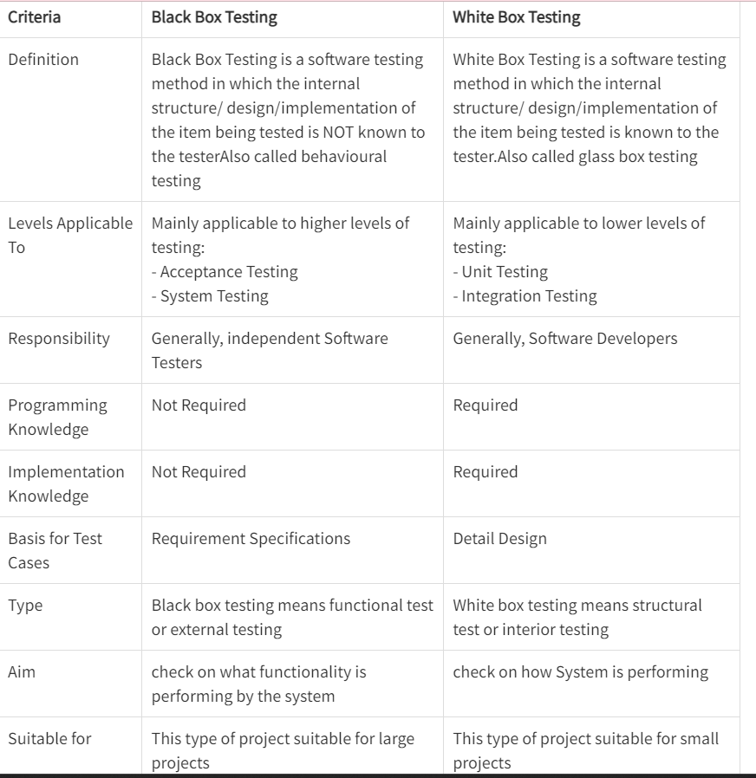

1. **Explain different types of testing.**

Software testing is the process of evaluation a software item to detect differences between given input and expected output. Also to assess the feature of A software item. Testing assesses the quality of the product. Software testing is a process that should be done during the development process. In other words software testing is a verification and validation process. Basics of software testing

There are two basics of software testing: blackbox testing and whitebox testing.

Blackbox Testing Black box testing is a testing technique that ignores the internal mechanism of the system and focuses on the output generated against any input and execution of the system. It is also called functional testing.

Whitebox Testing White box testing is a testing technique that takes into account the internal mechanism of a system. It is also called structural testing and glass box testing. Black box testing is often used for validation and white box testing is often used for verification.

Types of testing

There are many types of testing like

Unit Testing

Integration Testing

Functional Testing

System Testing

Stress Testing

Performance Testing

Usability Testing

Acceptance Testing

Regression Testing

Beta Testing

Unit Testing

Unit testing is the testing of an individual unit or group of related units. It falls under the class of white box testing. It is often done by the programmer to test that the unit he/she has implemented is producing expected output against given input.

Integration Testing

Integration testing is testing in which a group of components are combined to produce output. Also, the interaction between software and hardware is tested in integration testing if software and hardware components have any relation. It may fall under both white box testing and black box testing.

Functional Testing

Functional testing is the testing to ensure that the specified functionality required in the system requirements works. It falls under the class of black box testing.

System Testing

System testing is the testing to ensure that by putting the software in different environments (e.g., Operating Systems) it still works. System testing is done with full system implementation and environment. It falls under the class of black box testing.

Stress Testing

Stress testing is the testing to evaluate how system behaves under unfavorable conditions. Testing is conducted at beyond limits of the specifications. It falls under the class of black box testing.

Performance Testing

Performance testing is the testing to assess the speed and effectiveness of the system and to make sure it is generating results within a specified time as in performance requirements. It falls under the class of black box testing.

Usability Testing

Usability testing is performed to the perspective of the client, to evaluate how the GUI is user-friendly? How easily can the client learn? After learning how to use, how proficiently can the client perform? How pleasing is it to use its design? This falls under the class of black box testing.

Acceptance Testing

Acceptance testing is often done by the customer to ensure that the delivered product meets the requirements and works as the customer expected. It falls under the class of black box testing.

Regression Testing

Regression testing is the testing after modification of a system, component, or a group of related units to ensure that the modification is working correctly and is not damaging or imposing other modules to produce unexpected results. It falls under the class of black box testing.

Beta Testing Beta testing is the testing which is done by end users, a team outside development, or publicly releasing full pre-version of the product which is known as beta version. The aim of beta testing is to cover unexpected errors. It falls under the class of black box testing.

1. **Explain reverse engineering.**

Reverse engineering is taking apart an object to see how it works in order to duplicate or enhance the object. The practice, taken from older industries, is now frequently used on computer hardware and software. Software reverse engineering involves reversing a program's machine code (the string of 0s and 1s that are sent to the logic processor) back into the source code that it was written in, using program language statements.

Reverse-engineering is used for many purposes: as a learning tool; as a way to make new, compatible products that are cheaper than what's currently on the market; for making software interoperate more effectively or to bridge data between different operating systems or databases; and to uncover the undocumented features of commercial products.

**Following are reasons for reverse engineering a part or product:**

The original manufacturer of a product no longer produces a product

There is inadequate documentation of the original design

The original manufacturer no longer exists, but a customer needs the product

The original design documentation has been lost or never existed

Some bad features of a product need to be designed out. For example, excessive wear might indicate where a product should be improved

To strengthen the good features of a product based on long-term usage of the product

To analyze the good and bad features of competitors' product

To explore new avenues to improve product performance and features

To gain competitive benchmarking methods to understand competitor's products and develop better products

The original CAD model is not sufficient to support modifications or current manufacturing methods

The original supplier is unable or unwilling to provide additional parts

The original equipment manufacturers are either unwilling or unable to supply replacement parts, or demand inflated costs for sole-source parts

To update obsolete materials or antiquated manufacturing processes with more current, less-expensive technologies.

1. **Explain SCM Repositories.**

Software Configuration Management (SCM) is the process of managing software development and delivery by controlling and tracking changes to software artifacts, such as source code, documentation, and binary files. SCM repositories are the tools used to manage these artifacts and track changes to them.

A software repository is a central location where software artifacts are stored, managed, and shared. Some of the key functions of a software repository include:

Version control: A repository allows developers to track and manage changes to software artifacts over time. This ensures that multiple versions of the software can be maintained and changes can be tracked, rolled back, or merged as needed.

Collaboration: A repository facilitates collaboration between developers by allowing them to share and work on the same codebase. This is particularly useful in large projects where many developers are working on the same software.

Access control: A repository enables administrators to control who can access the software artifacts stored in the repository. This helps to protect intellectual property and maintain the integrity of the software.

Build and release management: A repository can be used to manage builds and releases of the software. This involves storing and managing the different versions of the software, as well as tracking and managing dependencies.

Documentation and reporting: A repository can be used to store documentation and generate reports on software artifacts. This can help developers and stakeholders understand the history and status of the software, as well as identify potential issues.

Integration with development tools: A repository can integrate with other development tools such as IDEs, build tools, and testing frameworks. This enables developers to work more efficiently and effectively, and helps to ensure that changes to the codebase are tracked and managed.

1. **Explain RMMM.**

A risk management technique is usually seen in the software Project plan. This can be divided into Risk Mitigation, Monitoring, and Management Plan (RMMM). In this plan, all works are done as part of risk analysis. As part of the overall project plan project manager generally uses this RMMM plan.

In some software teams, risk is documented with the help of a Risk Information Sheet (RIS). This RIS is controlled by using a database system for easier management of information i.e creation, priority ordering, searching, and other analysis. After documentation of RMMM and start of a project, risk mitigation and monitoring steps will start.

Risk Mitigation :

It is an activity used to avoid problems (Risk Avoidance).

Steps for mitigating the risks as follows.

Finding out the risk.

Removing causes that are the reason for risk creation.

Controlling the corresponding documents from time to time.

Conducting timely reviews to speed up the work.

Risk Monitoring :

It is an activity used for project tracking.

It has the following primary objectives as follows.

To check if predicted risks occur or not.

To ensure proper application of risk aversion steps defined for risk.

To collect data for future risk analysis.

To allocate what problems are caused by which risks throughout the project.

Risk Management and planning :

It assumes that the mitigation activity failed and the risk is a reality. This task is done by Project manager when risk becomes reality and causes severe problems. If the project manager effectively uses project mitigation to remove risks successfully then it is easier to manage the risks. This shows that the response that will be taken for each risk by a manager. The main objective of the risk management plan is the risk register. This risk register describes and focuses on the predicted threats to a software project.

Drawbacks of RMMM:

It incurs additional project costs.

It takes additional time.

For larger projects, implementing an RMMM may itself turn out to be another tedious project.

RMMM does not guarantee a risk-free project, infact, risks may also come up after the project is delivered.

1. **Explain Reengineering.**

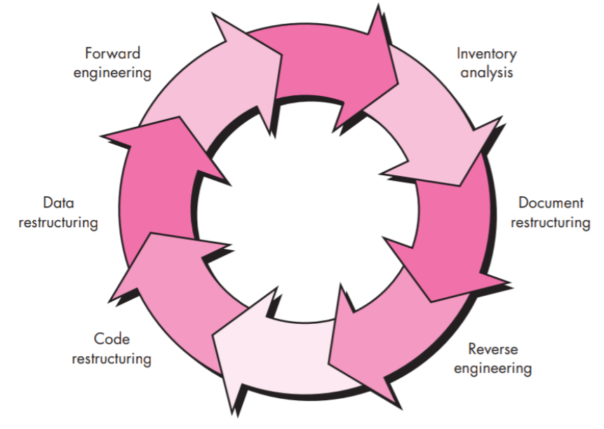

Software engineering covers not only the technical aspects of building software systems, but also management issues, such as directing programming teams, scheduling, and budgeting.

Software engineering is an engineering branch associated with development of software product using well-defined scientific principles, methods and procedures. The outcome of software engineering is an efficient and reliable software product.

Software project management has wider scope than software engineering process as it involves communication, pre and post-delivery support etc.

The need of software engineering arises because of higher rate of change in user requirements and environment on which the software is working.

**Large software**- It is easier to build a wall than to a house or building, likewise, as the size of software become large engineering has to step to give it a scientific process.

**Scalability**- If the software process were not based on scientific and engineering concepts, it would be easier to re-create new software than to scale an existing one.

**Cost**- As hardware industry has shown its skills and huge manufacturing has lower down the price of computer and electronic hardware. But the cost of software remains high if proper process is not adapted.

**Dynamic Nature**- The always growing and adapting nature of software hugely depends upon the environment in which user works. If the nature of software is always changing, new enhancements need to be done in the existing one. This is where software engineering plays a good role.

**Quality Management**- Better process of software development provides better and quality software product.

**RE Engineering:**

• Restructuring or rewriting part or all of a system without changing its functionality

• Applicable when some (but not all) subsystems of a larger system require frequent maintenance

• Reengineering involves putting in the effort to make it easier to maintain

• The reengineered system may also be restructured and should be re-documented

When do you decide to reengineer?

• When system changes are confined to one subsystem, the subsystem needs to be reengineered

• When hardware or software support becomes obsolete

• When tools to support restructuring are readily available

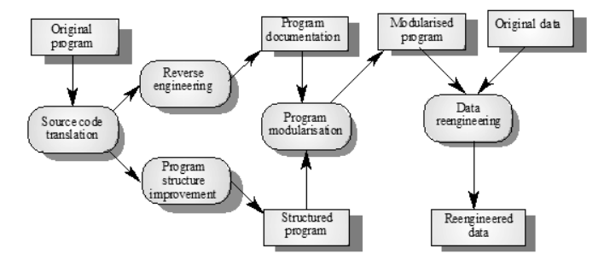

**Economics of Reengineering:**

• **Cost of maintenance**: cost annual of operation and maintenance over application lifetime

• **Cost of reengineering**: predicted return on investment reduced by cost of implementing changes and engineering risk factors

• **Cost benefit**: Cost of re engineering - Cost of maintenance

**Re-engineering advantages:**

**Reduced risk**

There is a high risk in new software development. There may be development problems, staffing problems and specification problems

**Reduced cost**

The cost of re-engineering is often significantly less than the costs of developing new software

The complete Software **Re-Engineering lifecycle** includes:

**Product Management:** Risks analysis, root cause analysis, business analysis, requirements elicitation and management, product planning and scoping, competitive analysis

**Research and Innovation**: Definition of a problem, data gathering and analysis, identifying a solution and developing best-of-breed or innovative algorithms, verification of quality for data and results, patent preparation

**Product Development:** Technology analysis and selection, software architecture and design, data architecture, deployment architecture, prototyping and production code development, comprehensive software testing, data quality testing, and product packaging and deployment preparation

**Product Delivery and Support**: Hardware/Platform analysis and selection, deployment and release procedures definition, installations and upgrades, tracking support issues, organizing maintenance releases.

**Project Management:** Brings efficiency and productivity to your software re-engineering project by utilizing modern, practical software project management, software quality assurance, data quality assurance, and advanced risk management techniques.

1. **With examples, differentiate between validation and verification.**

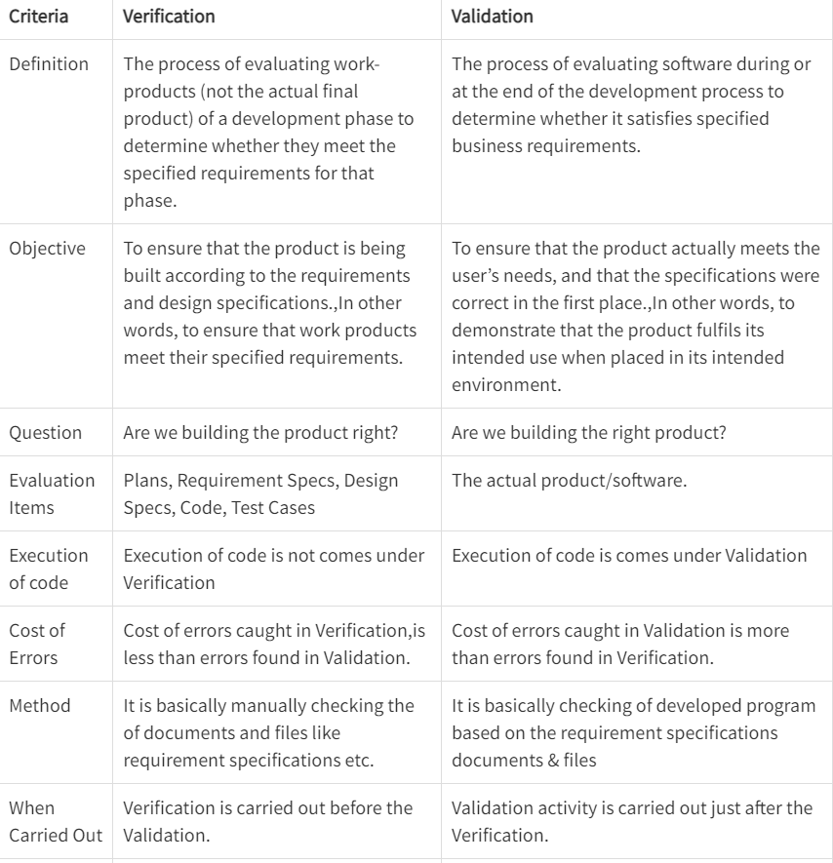

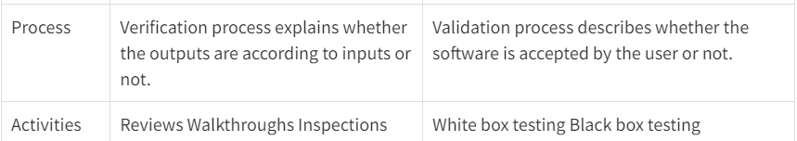

1. **Explain basis path testing and cyclomatic complexity with suitable examples.**

Path Testing:-

Path testing is a structural testing method that involves using the source code of a program in order to find every possible executable path. It helps to determine all faults lying within a piece of code. This method is designed to execute all or selected path through a computer program.

Basis Path Testing:-

The basis path testing is same, but it is based on a White Box Testing method, that defines test cases based on the flows or logical path that can be taken through the program. Basis path testing involves execution of all possible blocks in a program and achieves maximum path coverage with least number of test cases. It is a hybrid of branch testing and path testing methods.

The objective behind basis path testing is that it defines the number of independent paths, thus the number of test cases needed can be defined explicitly (maximizes the coverage of each test case).

Here we will take a simple example, to get better idea what is basis path testing include.

In the above example, we can see there are few conditional statements that is executed depending on what condition it suffice.

Here there are 3 path or condition that need to be tested to get the output,

• Path 1: 1,2,3,5,6, 7

• Path 2: 1,2,4,5,6, 7

• Path 3: 1, 6, 7

Basis Path Testing

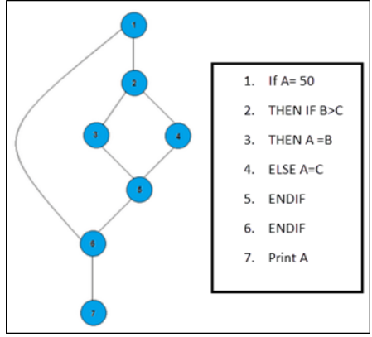

Steps for Basis Path testing

The basic steps involved in basis path testing include

• Draw a control graph (to determine different program paths)

• Calculate Cyclomatic complexity (metrics to determine the number of independent paths)

• Find a basis set of paths

• Generate test cases to exercise each path

Benefits of basis path testing

• It helps to reduce the redundant tests

• It focuses attention on program logic

• It helps facilitates analytical versus arbitrary case design

• Test cases which exercise basis set will execute every statement in program at least once.

Independent paths:

An independent path is any path through the graph that introduces at least one new set of processing statement or new condition. An independent path must move along at least one edge that has not been traversed before the path is defined.

cyclomatic complexity:

cyclomatic complexity can be designed through the given formula

v(6) = e - n + 2p

where

e is the no. of edges

n is the no. of nodes in the graph

p is the no. of components in the whole graph.

void main c { int a, b, c, max,

1. print f ('enter 3 integers"),
2. scan f (" %d %d %d", & a, & , & c),b
3. if (a >) b
4. if ( a > c)
5. Max = a
6. else max = c,
7. else if (b > c)
8. Max = b
9. else max = c

10.print and ( "a max = % d", max), 3

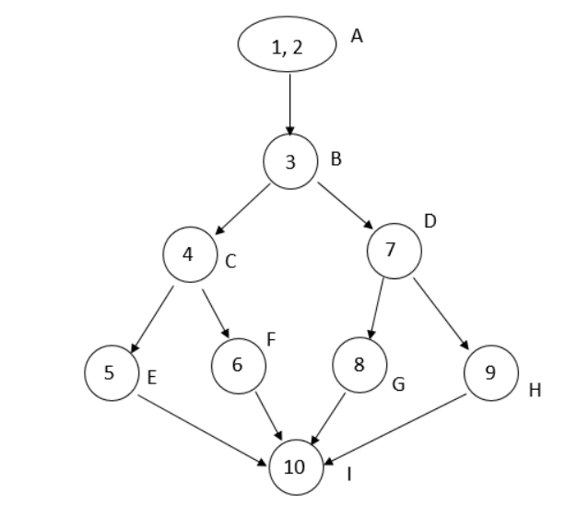

No. of independent paths

v (a) = e - n + 2

= 11 - 9 + 2

= 4

No. of procedures = 1

∴

cyclomatic complexity

= e - n + 2 P

= 11 - 9 + 2

= 4

1. **Explain the different OO testing methods.**

Object Oriented Testing methods:

Testing is a continuous activity during software development. In object-oriented systems, testing encompasses three levels, namely, unit testing, subsystem testing, and system testing.

Unit Testing:

In unit testing, the individual classes are tested. It is seen whether the class attributes are implemented as per design and whether the methods and the interfaces are error-free.

Unit testing is the responsibility of the application engineer who implements the structure.

Subsystem Testing:

This involves testing a particular module or a subsystem and is the responsibility of the subsystem lead. It involves testing the associations within the subsystem as well as the interaction of the subsystem with the outside.

Subsystem tests can be used as regression tests for each newly released version of the subsystem.

System Testing:

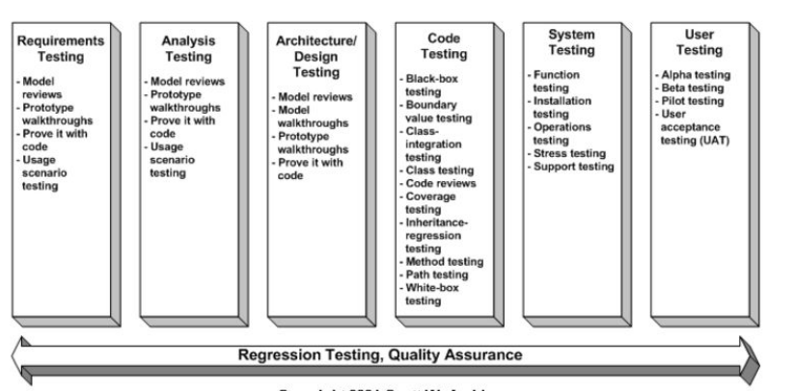

System testing involves testing the system as a whole and is the responsibility of the quality-assurance team. The team often uses system tests as regression tests when assembling new releases. enter image description here

Object-Oriented Testing Techniques:

Grey Box Testing:

The different types of test cases that can be designed for testing object-oriented programs are called grey box test cases. Some of the important types of grey box testing are:

State model based testing: This encompasses state coverage, state transition coverage, and state transition path coverage.

Use case based testing: Each scenario in each use case is tested.

Class diagram based testing: Each class, derived class, associations, and aggregations are tested.

Sequence diagram based testing: The methods in the messages in the sequence diagrams are tested.

Techniques for Subsystem Testing:

The two main approaches of subsystem testing are:

Thread based testing: All classes that are needed to realize a single use case in a subsystem are integrated and tested.

Use based testing: The interfaces and services of the modules at each level of hierarchy are tested. Testing starts from the individual classes to the small modules comprising of classes, gradually to larger modules, and finally all the major subsystems.

Categories of System Testing:

Alpha testing: This is carried out by the testing team within the organization that develops software.

Beta testing: This is carried out by select group of co-operating customers.

Acceptance testing: This is carried out by the customer before accepting the deliverables.

Black-box testing:

Testing that verifies the item being tested when given the appropriate input provides the expected results.

Boundary-value testing:

Testing of unusual or extreme situations that an item should be able to handle.

Class testing:

The act of ensuring that a class and its instances (objects) perform as defined.

Component testing:

The act of validating that a component works as defined.

Inheritance-regression testing:

The act of running the test cases of the super classes, both direct and indirect, on a given subclass.

Integration testing:

Testing to verify several portions of software work together.

Model review:

An inspection, ranging anywhere from a formal technical review to an informal walkthrough, by others who were not directly involved with the development of the model.

Path testing:

The act of ensuring that all logic paths within your code are exercised at least once.

Regression testing:

The acts of ensuring that previously tested behaviors still work as expected after changes have been made to an application.

Stress testing:

The act of ensuring that the system performs as expected under high volumes of transactions, users, load, and so on.

Technical review:

A quality assurance technique in which the design of your application is examined critically by a group of your peers. A review typically focuses on accuracy, quality, usability, and completeness. This process is often referred to as a walkthrough, an inspection, or a peer review.

User interface testing:

The testing of the user interface (UI) to ensure that it follows accepted UI standards and meets the requirements defined for it. Often referred to as graphical user interface (GUI) testing.

White-box testing:

Testing to verify that specific lines of code work as defined. Also referred to as clear-box testing.

1. **What is maintenance and different types? Explain the steps for creating the maintenance log.**

Software maintenance is the process of modifying and updating a software application after it has been deployed in order to correct defects, improve performance, or adapt the software to changing requirements. There are four different types of maintenance:

1. Corrective maintenance: This type of maintenance involves fixing defects or errors in the software. Corrective maintenance is typically performed in response to user complaints or bug reports.

2. Adaptive maintenance: This type of maintenance involves modifying the software to accommodate changes in the environment, such as changes in operating systems or hardware.

3. Perfective maintenance: This type of maintenance involves improving the functionality of the software in response to changing requirements or to address user feedback.

4. Preventive maintenance: This type of maintenance involves making changes to the software in order to prevent future problems, such as improving security or enhancing performance.

Creating a maintenance log is an important part of software maintenance. A maintenance log is a record of all the maintenance activities performed on the software, including the date, description of the activity, and the person who performed the activity. The following are the steps for creating a maintenance log:

1. Identify the maintenance activities: Determine what maintenance activities need to be performed on the software. This may include bug fixes, performance improvements, or feature enhancements.

2. Assign responsibility: Assign responsibility for each maintenance activity to a specific person or team.

3. Set priorities: Prioritize the maintenance activities based on their importance and urgency.

4. Schedule maintenance: Determine when each maintenance activity will be performed and schedule it accordingly.

5. Document maintenance activities: Document each maintenance activity in the maintenance log, including the date, description of the activity, and the person who performed the activity.

6. Review the log: Regularly review the maintenance log to ensure that all maintenance activities are being performed as scheduled and to identify any issues that need to be addressed.

In summary, software maintenance is the process of modifying and updating a software application after it has been deployed. There are four different types of maintenance, including corrective, adaptive, perfective, and preventive. Creating a maintenance log is an important part of software maintenance, and involves identifying maintenance activities, assigning responsibility, setting priorities, scheduling maintenance, documenting maintenance activities, and regularly reviewing the log.

1. **Project Life Cycle?**

The project life cycle (PLC) is a collection of logical stages or phases

that maps the life of a project from its beginning to its end in order to

define, build, and deliver the product of a project—that is, the

product, service, or information system.

Each phase should provide one or more deliverables. A deliverable is

a tangible and verifiable product of work (i.e., project plan, design

specifications, delivered system, etc.).

Deliverables at the end of each phase also provide tangible benefits

throughout the project and serve to define the work and resources

needed for each phase.

The project life cycle refers to the stages that a project goes through from its initiation to its completion. The project life cycle typically consists of four main phases:

1. Initiation: This is the first phase of the project life cycle, where the project is defined, authorized, and initiated. The purpose of this phase is to identify the business need for the project, determine its feasibility, and create a preliminary project plan. The main outputs of this phase include a project charter, a feasibility study, and a preliminary project plan.

2. Planning: In the planning phase, the project plan is developed in detail. The purpose of this phase is to define the scope, objectives, deliverables, and activities required to complete the project successfully. The main outputs of this phase include a detailed project plan, a schedule, a budget, a risk management plan, and a quality plan.

3. Execution: In the execution phase, the project plan is put into action. The purpose of this phase is to deliver the project deliverables as per the plan. The main activities of this phase include procuring resources, managing project progress, monitoring and controlling project risks, and communicating project status to stakeholders.

4. Closure: The closure phase marks the end of the project. The purpose of this phase is to formally close the project, transfer project deliverables to the customer, and conduct a post-project review. The main outputs of this phase include a final project report, a lessons learned document, and a project closure report.

The project life cycle provides a framework for managing projects, and each phase is designed to achieve specific objectives. By following a structured approach to project management, project managers can ensure that projects are completed on time, within budget, and to the satisfaction of stakeholders.

1. **Project management and need for it:**

**Defines a plan and organizes chaos**

Projects are naturally chaotic.

The primary business function of project management is organizing and planning projects to tame this chaos.

A clear path mapped out from start to finish ensures the outcome meets the goals of your project.

Establishes a schedule and plan

Without a schedule, a project has a higher probability of delays and cost overruns. A sound schedule is key to a successful project.

Enforces and encourages teamwork

A project brings people together to share ideas and provide inspiration.

Collaboration is the cornerstone to effective project planning and management.

Maximizes resources

Resources, whether financial or human, are expensive.

By enforcing project management disciplines such as project tracking and risk management, all resources are used efficiently and economically.

Manages Integration

Projects don’t happen in a vacuum.

They need to be integrated with business processes, systems and organizations.

You can’t build a sales system that doesn’t integrate with your sales process and sales organization. It wouldn’t add much value.

Integration is often key to project value.

Project management identifies and manages integration.

Controls cost

some projects can cost a significant amount of money so on budget performance is essential.

Using project management strategies greatly reduces the risk of budget overruns.

Manages change

projects always happen in an environment in which nothing is constant except change.

Managing change is a complex and daunting task. It is not optional.

Project management manages change.

Managing quality

Quality is the value of what you produce.

Project management identifies, manages and controls quality.

This results in a high quality product or service and a happy client.

Retain and Use Knowledge

projects generate knowledge or at least they should.

Knowledge represents a significant asset for most businesses.

Left unmanaged knowledge tends to quickly fade.

Project management ensures that knowledge is captured and managed.

Learning from Failure

projects do fail.

When they do, it is important to learn from the process.

Project management ensures that lessons are learned from project success and failure.

1. **Request for Proposal:**

A request for proposal (RFP) is a formal document that an

organization uses when it wants to buy a product or service.

A company publishes the RFP that includes a detailed explanation of

what you want and why, and uses it to solicit bids and identify the

best partner in developing the product.

It is a competitive process in which several companies may submit

proposals.

The RFP outlines what your organization is looking for and how it will

evaluate proposals. It typically includes information in the following

categories:

Technical: Describe the business objectives of the project and details about

the scope of the project including development, standards, outcomes, and

deliverables.

Administrative: Provide information about the company issuing the RFP,

including its history, organization, and operations.

Financial: Outline information about the company's business plan, financial

data, and risk analysis.

1. **Business Case**

Step 1: Select the Core Team

Rather than have one person take sole responsibility for developing

the business case, a core team should be recruited.

If possible, developing a business case should include many of the

stakeholders affected by the project or involved in its delivery.

The core team should, therefore, include managers, business

specialists, and users who understand the requirements to be met, as

well as IT specialists who understand the opportunities, limitations,

and risks associated with IT.

Step 2. Define Measurable Organizational Value

(MOV)

The core team’s objective should be to define the problem or opportunity and

then identify several alternatives that will provide direct and measurable value to

the organization.

To provide real value to an organization, however, IT projects must align with and support the organization’s goals, mission, and objectives.

Therefore, any recommended alternative by the core team must have a clearly

defined purpose and must map to the goals and strategy of the organization.

The goal of the project then becomes the project’s measure of success.

In the IT project management methodology, the project’s overall goal and

measure of success is referred to as the project’s measurable organizational

value (MOV).

Step 3: Identify Alternatives

Since no single solution generally exists for most organizational problems,

it is imperative to identify several alternatives before dealing directly with a

given business opportunity.

The alternatives, or options, identified in the business case should be

strategies for achieving the MOV.

It is also important that the alternatives listed include a wide range of

potential solutions as well as a base case alternative that describes how the

organization would perform if it maintained the status quo—that is, if it did

not pursue any of the options described in the business case. In some

situations, maintaining the status quo may be the best alternative.

It is important to be open to and objective on all viable options.

Step 3: Identify Alternatives

The base case should also delve into the realistic costs of maintaining

the current system over time.

Include such things as increased maintenance costs of hardware and

software, as well as the possibility for more frequent system failures

and downtime.

However, if the demand for service decreases, maintaining a legacy

system may be a more viable alternative than a proposed new

system.

Step 4: Define Feasibility and Assess Risk

Each option or alternative must be analyzed in terms of its feasibility

and potential risk.

Feasibility should focus on whether a particular alternative is doable

and worth doing.

Risk, on the other hand, focuses on what can go wrong and what

must go right.

Analyzing the feasibility and risk of each alternative at this point may

act as a screening process for ruling out any alternatives that are not

worth pursuing.

Step 4: Define Feasibility and Assess Risk

Feasibility may be viewed in terms of:

Economic feasibility

Technical feasibility

Organizational feasibility

Other feasibilities such as legal and ethical feasibility etc.

Risk should focus on:

Identification—What can go wrong? What must go right?

Assessment—What is the impact of each risk?

Response—How can the organization avoid or minimize the risk?

Step 5: Define Total Cost of Ownership

The decision to invest in an IT project must take into account all of the

costs associated with the application system.

Total Cost of Ownership (TCO) is a concept that has gained widespread

attention and generally refers to the total cost of acquiring, developing,

maintaining, and supporting the application system over its useful life.

TCO includes such costs as:

Direct or up-front costs—Initial purchase price of all hardware, software, and

telecommunications equipment, all development or installation costs, outside

consultant fees, etc.

Ongoing costs—Salaries, training, upgrades, supplies, maintenance, etc.

Indirect costs—Initial loss of productivity, time lost by users when the system is

down, the cost of auditing equipment (i.e., finding out who has what and where),

quality assurance, and post-implementation reviews

Step 6: Define Total Benefits of Ownership

The Total Benefits of Ownership (TBO) must include all of the direct,

ongoing, and indirect benefits associated with each proposed alternative.

The TBO should address the benefits of an alternative over the course of its

useful life.

Benefits can arise from:

Increasing high-value work—For example, a salesperson may spend less time on

paperwork and more time calling on customers

Improving accuracy and efficiency—For example, reducing errors, duplication, or

the number of steps in a process

Improving decision making—For example, providing timely and accurate

information

Improving customer service—For example, new products or services, faster or more reliable service, convenience, and so on

Step 7: Analyze Alternatives

Once costs and benefits have been identified, it is important that all

alternatives be compared with each other consistently.

Understanding the financial and numeric tools and techniques required by

financial people and senior management is critical, even for the technically

savvy.

Being able to communicate effectively using their terms and tools increases

one’s credibility and the chances of getting projects approved and funded.

There are several ways to analyze the proposed alternatives. The most

common are financial models scoring models

Step 8: Propose and Support the Recommendation

Once the alternatives have been identified and analyzed, the last step is to

recommend one of the options.

It is important to remember that a proposed recommendation must be

supported.

If the analysis was done diligently, this recommendation should be a

relatively easy task.

The business case should be formalized in a professional-looking report.

Remember that the quality and accuracy of your work will be a reflection

on you and your organization.

A potential client or project sponsor may not give you a second chance.

1. **What are the PMBOK areas?**

The Project Management Body of Knowledge (PMBOK) is a guide that provides a framework for project management. The PMBOK includes 10 knowledge areas, which are as follows:

**Project Integration Management:** This knowledge area focuses on the processes and activities involved in coordinating and integrating all aspects of the project, including scope, schedule, budget, and resources.

**Project Scope Management:** This knowledge area focuses on defining, managing, and controlling the scope of the project, including the requirements and deliverables.

**Project Schedule Management:** This knowledge area focuses on developing, managing, and controlling the project schedule, including defining the activities, sequencing them, and estimating their durations.

**Project Cost Management:** This knowledge area focuses on estimating, budgeting, and controlling the costs of the project, including monitoring and controlling project expenses.

**Project Quality Management:** This knowledge area focuses on ensuring that the project meets the defined quality standards and requirements, including planning and executing quality control activities.

**Project Resource Management:** This knowledge area focuses on managing and controlling the resources required to complete the project, including human resources, materials, and equipment.

**Project Communications Management:** This knowledge area focuses on planning, managing, and controlling project communications, including stakeholder communications, progress reporting, and risk management.

**Project Risk Management:** This knowledge area focuses on identifying, assessing, and managing project risks, including developing risk response plans and monitoring and controlling risks throughout the project.

**Project Procurement Management:** This knowledge area focuses on planning, managing, and controlling project procurement, including contracting with vendors and managing procurement-related risks.

**Project Stakeholder Management:** This knowledge area focuses on identifying and managing project stakeholders, including developing and executing stakeholder engagement strategies, and addressing stakeholder concerns and issues.

Each of these knowledge areas is important to the successful planning and execution of a project, and they are interconnected and interdependent. Project managers must consider all 10 knowledge areas and their interactions when planning and managing a project.

1. **Differentiate between alpha and beta testing.**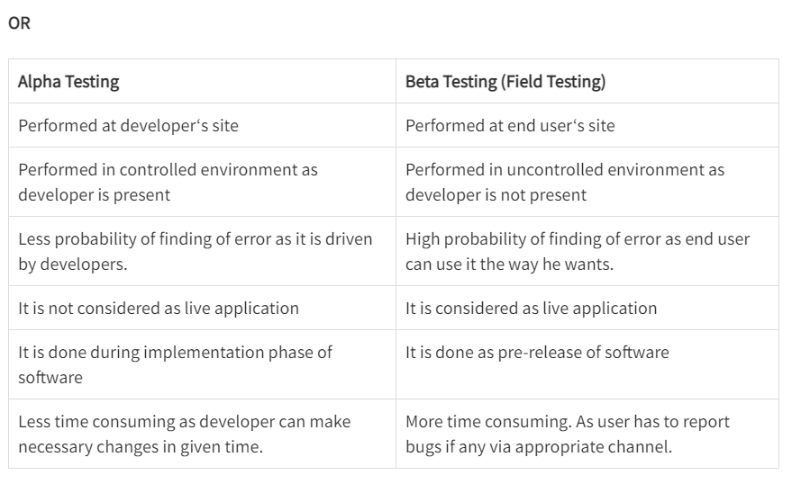

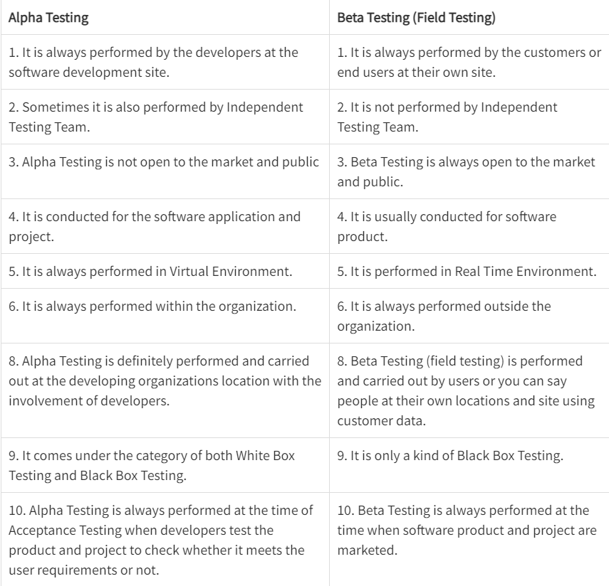

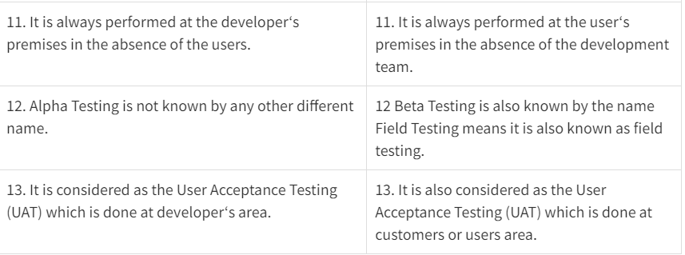

1. **Short note on test driven development.**

Test Driven Development is the process in which test cases are written before the code that validates those cases. It depends on repetition of a very short development cycle. Test driven Development is a technique in which automated Unit test are used to drive the design and free decoupling of dependencies.

The following sequence of steps is generally followed:

1. Add a test – Write a test case that describe the function completely. In order to make the test cases the developer must understand the features and requirements using user stories and use cases.
2. Run all the test cases and make sure that the new test case fails.
3. Write the code that passes the test case.
4. Run the test cases.
5. Refactor code – This is done to remove duplication of code.
6. Repeat the above mentioned steps again and again.

Motto of TDD:

1. Red – Create a test case and make it fail
2. Green – Make the test case pass by any means.
3. Refactor – Change the code to remove duplicate/redundancy.

Benefits:

1. Unit test provides constant feedback about the functions.
2. Quality of design increases which further helps in proper maintenance.
3. Test driven development act as a safety net against the bugs.
4. TDD ensures that your application actually meets requirements defined for it.
5. TDD have very short development lifecycle.
6. **Describe boundary value analysis with suitable examples.**

Functional testing is a type of software testing in which the system is tested against the functional requirements of the system. It is conducted to ensure that the requirements are properly satisfied by the application. Functional testing verifies that each function of the software application works in conformance with the requirement and specification. Boundary Value Analysis(BVA) is one of the functional testings.

Boundary Value Analysis is based on testing the boundary values of valid and invalid partitions. The behavior at the edge of the equivalence partition is more likely to be incorrect than the behavior within the partition, so boundaries are an area where testing is likely to yield defects.

It checks for the input values near the boundary that have a higher chance of error. Every partition has its maximum and minimum values and these maximum and minimum values are the boundary values of a partition.

Note:

A boundary value for a valid partition is a valid boundary value.

A boundary value for an invalid partition is an invalid boundary value.

For each variable we check-

* Minimum value.
* Just above the minimum.
* Nominal Value.
* Just below Max value.
* Max value.

Example: Consider a system that accepts ages from 18 to 56.

Valid Test cases: Valid test cases for the above can be any value entered greater than 17 and less than 57.

Enter the value- 18.

Enter the value- 19.

Enter the value- 37.

Enter the value- 55.

Enter the value- 56.

Invalid Test cases: When any value less than 18 and greater than 56 is entered.

Enter the value- 17.

Enter the value- 57.

1. **Write a note on: Schedule and Cost slippage.**

Schedule and cost slippage are two important concepts in project management that refer to delays in the project schedule or cost overruns, respectively.

Schedule slippage occurs when the project timeline extends beyond the planned completion date. This delay can occur due to a variety of factors, such as unexpected technical problems, resource constraints, or changes in project scope. Schedule slippage can be measured in terms of the difference between the planned completion date and the actual completion date.

Cost slippage, on the other hand, occurs when the actual cost of the project exceeds the planned cost. This can happen due to various reasons, such as scope creep, unexpected expenses, or inaccurate cost estimates. Cost slippage can be measured in terms of the difference between the planned cost and the actual cost.

Both schedule and cost slippage can have negative impacts on the project, such as decreased stakeholder satisfaction, increased project risks, and decreased profitability. Therefore, it is important for project managers to monitor and control these factors to avoid or minimize their impacts.

To address schedule slippage, project managers can take various actions, such as adjusting the project schedule, allocating additional resources, or prioritizing critical activities. Similarly, to address cost slippage, project managers can take actions such as re-estimating project costs, negotiating with suppliers or contractors, or reducing project scope.

Overall, schedule and cost slippage are important indicators of project performance that can help project managers to identify potential issues and take corrective actions to keep the project on track.

1. **Explain the relationship among scope, schedule, and budget?**

Scope, schedule, and budget are three key components of any project and are closely interrelated. The scope of a project defines the goals, objectives, deliverables, and requirements, while the schedule outlines the timeline for completing the project, and the budget defines the resources required to complete the project.

The relationship among these three components can be summarized as follows:

Scope and Schedule: The scope of the project directly impacts the schedule, as it defines the deliverables and requirements that must be completed within a specific timeframe. The schedule must be designed to accommodate the scope of the project, ensuring that all deliverables are completed on time and within the defined timeline.

Scope and Budget: The scope of the project also impacts the budget, as it defines the resources required to complete the project. The budget must be designed to accommodate the scope of the project, ensuring that the required resources are available to complete all deliverables and requirements.

Schedule and Budget: The schedule and budget are closely interrelated, as the timeline for completing the project and the resources required to complete the project must be aligned. The budget must be designed to accommodate the project schedule, ensuring that the required resources are available at the right time to complete each deliverable.

Overall, scope, schedule, and budget are interrelated and must be carefully managed throughout the project lifecycle. Project managers must ensure that the project scope, schedule, and budget are aligned and that changes to one component are carefully evaluated to ensure that they do not impact the others. Effective management of these three components is critical to the success of any project.

1. **What is a Project? What are the attributes of a project?**

A project can be defined as a temporary endeavour undertaken to accomplish a unique product, services or results.

Project can be sequences of task which is planned from beginning to end bounded by time, resources, and required result.

The Following are the attributes of Project:

a. Time frame: Because a project is a temporary endeavour, it must have a definite beginning and end. Many projects begin on a specific date and the date of completion is estimated. Some project has an immovable date when the project must be completed.

b. Purpose: An IT Project can produce any number of results such as a system, a software package, or a recommendation based on a study. Therefore a project’s goal must be to produce something tangible and of value to the organization. A Project must have a goal to drive the project in terms of defining the work to be done.

c. Ownership: The project must provide something of value to an individual or group who will own the project product after it is completed. Determining who owns this project is not always easy. For example, different groups may fight over the does and does not own the system, the data, the support, and the final cost of implementing and maintaining the system.

d. Resources: IT project require time, money, people, and technology. Resources provide the means for achieving a project’s goal and also act as a constraint. For example, the project’s scope, or work to be accomplished is determined directly by the project’s goal. If project sponsor asks that an additional feature to be added to the system, however, this will required additional resources in terms of more work on the part of project team.

e. Roles: IT Projects require different individuals with different skills set, they are listed below.

1. Project Manager: She/he is responsible for ensuring that all of the project management and technical development processes are in place and being carried out properly.

2. Project sponsor: The project sponsor may be the client, customer, or organizational resources manager who will act as champion for the project.

3. Subject matter experts: The subject matter expert may be user or client who has specific knowledge, expertise, or insight in a specific functional area.

4. Technical Expert: Technical expert is needed to provide a technical solution to organization problems.

Risks and Assumptions: All projects have an element risk. Risk can arise from many sources, both and external and internal to the project team. For example, internal risk may arise from estimation process. On other hand, external risk may arise due to dependencies on other contractors or vendors.

Interdependent Tasks: Project work requires many interdependent tasks. For example, a network cannot an installed until the hardware is delivered. Or certain requirements cannot be incorporated into design until key user is interviewed.

Organizational Change: Project is planned organizational change. Change must be understood and managed because implementation of the IT project will change the ways people work.

Operating in an Environment Larger than the project itself: Organization chooses projects for a number of reasons, and the projects chosen can impact the organization.

Project Management: Project management is the applications of knowledge, skills, tools and techniques to project activities to meet project requirements. The planning and organization of an organization's resources in order to move a specific task, event or duty toward completion. Project management typically involves a one-time project rather than an ongoing activity, and resources managed include both human and financial capital.

1. **Explain how Gantt Chart can be used for planning and controlling small projects with suitable examples? What are the limitations of the Gantt chart?**

Gantt Chart:

The Gantt chart is actually a modified bar chart in which horizontal bars are drawn for each activity in proportion to the time required for completing it.

It is frequently used to keep track of multiple machine schedules.

This chart provides an immediate comparison between schedule and reality (i.e. planned work and actual progress of work.)

This is achieved simply by marking the planned work and the actual progress of work on the chart.

A cursor attached to the Gantt chart can be moved across the chart to compare between the actual progress and planned work till any particular date.

Advantages of Gantt chart :

* It is simple graphical display techniques , suitable for less complex situations.
* It is extremely easy to understand.
* There is clarity in communicating important shop information by using Gantt chart
* It can quickly reveal the current or planned situation to all concerned.

Disadvantages of Gantt chart :

* The Gantt chart must be updated periodically to account for new jobs.
* It is used for communicating relatively less information.
* Required greater time to maintain.
* Lack of adequate depiction interrelationship between the separate tasks.

1. **What are the advantages of including milestones in the WBS? Why should the WBS be deliverable oriented?**

A Work Breakdown Structure includes dividing a large and complex project into simpler, manageable and independent tasks. The root of this tree (structure) is labeled by the Project name itself. For constructing a work breakdown structure, each node is recursively decomposed into smaller sub-activities, until at the leaf level, the activities becomes undividable and independent. It follows a Top-Down approach.

Steps:

Step-1: Identify the major activities of the project.

Step-2: Identify the sub-activities of the major activities.

Step-3: Repeat till undividable, simple and independent activities are created.

Firstly, the project managers and top level management identifies the main deliverables of the project. After this important step, these main deliverables are broken down into smaller higher-level tasks and this complete process is done recursively to produce much smaller independent tasks. It depends on the project manager and team that upto which level of detail they want to break down their project.

Generally the lowest level tasks are the most simplest and independent tasks and take less than two weeks worth of work. Hence, there is no rule for upto which level we may build the work breakdown structure of the project as it totally depends upon the type of project we are working on and the management of the company. The efficiency and success of the whole project majorly depends on the quality of the Work Breakdown Structure of the project and hence, it implies its importance.

Uses:

* It allows us to do a precise cost estimation of each activity.
* It allows us to estimate the time that each activity will take more precisely.
* It allows easy management of the project.
* It helps in proper organization of the project by the top management.

1. **What do you mean by Project Charter and Plan? Are they different?**

A project charter, also known as a project definition document, is a brief official record of a planned project. It outlines the project's scope, including the objectives, goals, stakeholders and teams that support the work. An organization uses a project charter to obtain the authorization of stakeholders to begin a project. The company's stakeholders may sign off on the project charter, signifying that the scope meets the needs and expectations of the group.

A project charter functions as a sales document, selling the proposed project idea to the organization's stakeholders. Usually, as a one-page document, it outlines the following criteria for presentation to upper management, a board of directors or other essential company stakeholders:

* The objectives of the project and expected benefits
* Direction regarding the project's outcome
* A list of stakeholders, including team members and external customers
* The assigned project manager and identified key roles
* Specific key deliverables and significant milestones
* A list of risks, potential issues, constraints and assumptions
* A proposed project budget
* Acceptance and approval criteria

Once the organization's stakeholders approve of the project charter, the project manager's first responsibility is to create the project plan.

A project plan, also known as a work plan, outlines the project scope and objectives based on the project charter. The project plan identifies the specific instructions for executing and managing the project. It also determines the milestones and deadlines, each person's responsibilities and the organizational structure of the project team. Both documents work together to provide a detailed record of successful project management.

A project plan functions as the operating manual to carry out the project to completion. Once the stakeholders approve the project charter, the project manager creates the project plan using the charter's objective and scope. It then outlines specific elements of the project, including:

* The value of the project to the organization and stakeholders
* The timeline of the project and particular milestones
* The organizational structure of the project team
* The responsibilities of the key roles involved in the project
* The identification of individuals who fill vital roles
* The allocation of resources required, such as technology needed
* The nature of the work necessary to meet the objectives
* The tasks and particular activities needed to complete the project
* The determination of the work breakdown structure (WBS)

Once the project manager completes the project plan, they use it to communicate with the stakeholders regarding the project's progress. They also use it to provide further detail to the project planning process. For example, a project manager uses the plan to build out a risk assessment or quality planning strategy.

1. **Explain in detail 4 P's of project management.**

For properly building a product, there’s a very important concept that we all should know in software project planning while developing a product. There are 4 critical components in software project planning which are known as the 4P’s namely: People, Product, Process, Project

* **People**

The most important component of a product and its successful implementation is human resources. In building a proper product, a well-managed team with clear-cut roles defined for each person/team will lead to the success of the product. We need to have a good team in order to save our time, cost, and effort. Some assigned roles in software project planning are project manager, team leaders, stakeholders, analysts, and other IT professionals. Managing people successfully is a tricky process which a good project manager can do.

* **Product**

As the name inferred, this is the deliverable or the result of the project. The project manager should clearly define the product scope to ensure a successful result, control the team members, as well technical hurdles that he or she may encounter during the building of a product. The product can consist of both tangible or intangible things such as shifting the company to a new place or getting a new software in a company.

* **Process**

In every planning, a clearly defined process is the key to the success of any product. It regulates how the team will go about its development in the respective time period. The Process has several steps involved like, documentation phase, implementation phase, deployment phase, and interaction phase.

* **Project**

The last and final P in software project planning is Project. It can also be considered as a **blueprint of process**. In this phase, the project manager plays a critical role. They are responsible to guide the team members to achieve the project’s target and objectives, helping & assisting them with issues, checking on cost and budget, and making sure that the project stays on track with the given deadlines.

1. 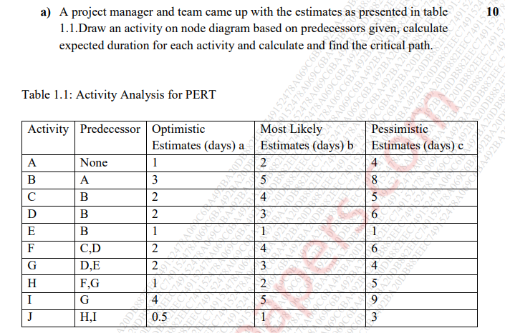

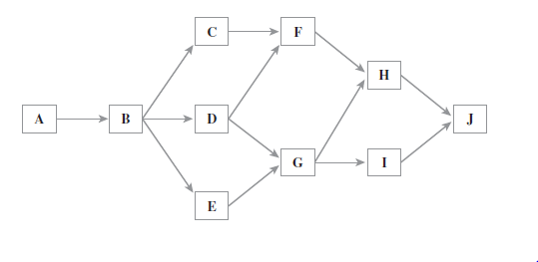

Expected Duration Calculation

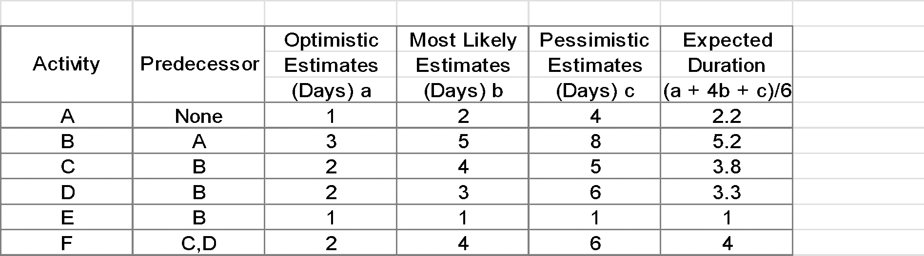

**Critical Path Calculation**

Possible PERT Activity Paths

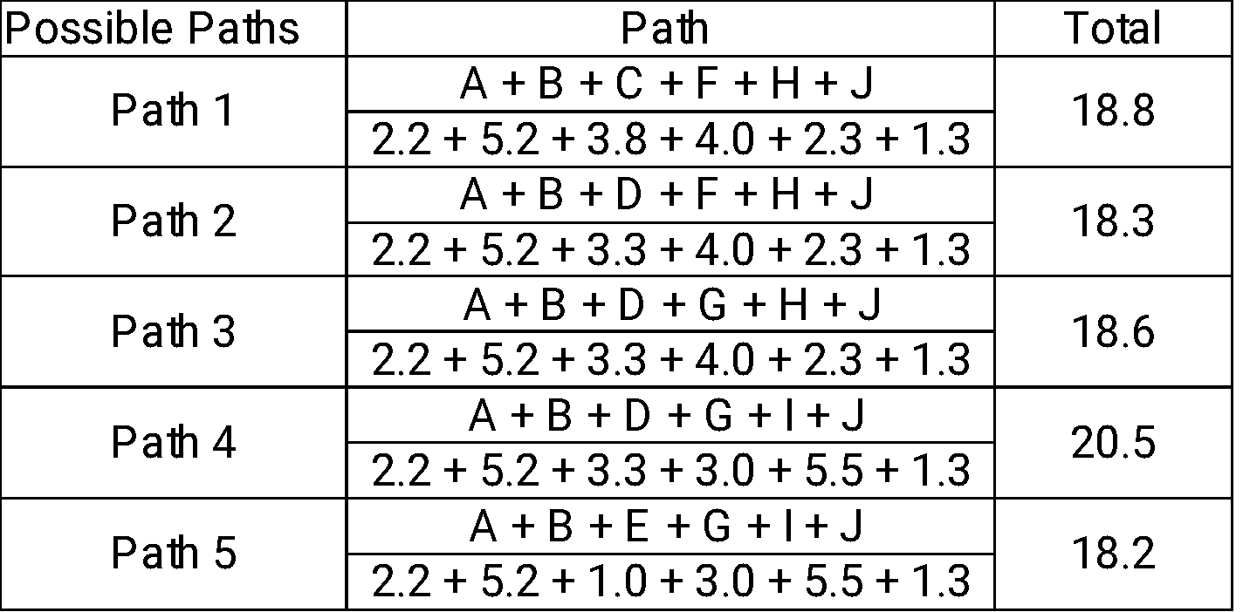

Path 4 is critical path with 21 days duration.

**75**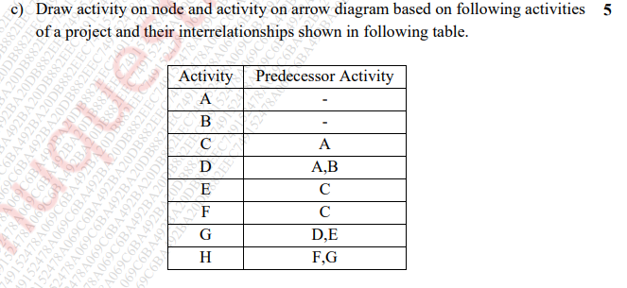

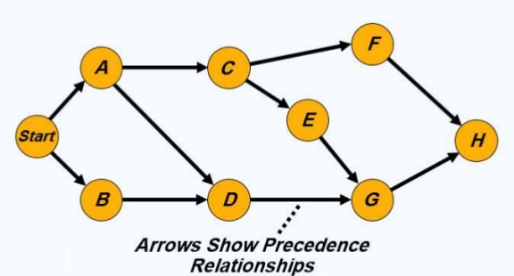

**Activity on Arrow**

